LoveQuest Project #5

A-Squad

Quatoria Abadi, Armel Atayi, Adithya Bikki,

# Introduction

Link to project -   
https://www.figma.com/file/pCXlcx38KxFVnYrrlGVFHm/Project-5?type=design&node-id=189%3A1184&mode=design&t=VlxDdr51Rck7Rt0U-1 Links to an external site.

Waiting for your partner? Say no more with the LoveQuest app, where you can embark on an exciting journey to find them. Our app is equipped with a range of features designed to streamline your search and enhance your experience. With the Basic Search function, you can effortlessly filter through potential matches based on your preferences, while the Detail Review feature allows you to delve deeper into each profile to make informed decisions. And when you're ready to connect, our seamless communication tools enable you to engage with your matches through messaging and even video chat. Say goodbye to waiting and hello to endless possibilities with LoveQuest. Download now and start your journey to love today!

* **Basic Search (Armel) -** In this task, users have the opportunity to customize their dating app experience by setting their preferences. They can select from a diverse range of criteria including Gender, Age, Desire for Children, Hobbies, and Relationship Type. By tailoring these preferences, users will be matched with individuals who align with their desired criteria, enhancing the likelihood of meaningful connections.
* **Detail review (Adithya) -** In this task, users have the flexibility of viewing and managing profiles of their potential matches. They can even rate their mates based on their feelings and feedback. Along with reviews, they can even like the profiles for quicker access. With this feature, they can efficiently manage all the profiles and pin important matches for quicker access and retrieval.
* **Communication (Quatoria) -** In this task, users of the "Love Quest" app dive into a vibrant communication hub, connecting with potential partners through text, video calls, and innovative video messages. With interactive features like virtual gifts and personalized recordings, users explore compatibility and foster intimacy, each conversation holding the promise of something special, be it a lifelong bond or a fleeting connection.
* **Additional Choice (Anitra)**

# 

# Task #1 - Basic Search (Armel)

## Introduction

Welcome to the LoveQuest Basic Search Feature, your gateway to tailored romantic exploration. Dive into a world of personalized preferences to discover your perfect match. Choose your preferred gender—whether it's men, women, or both—and define the nature of your desired relationship, whether it's polyamorous or monogamous. Specify the age range of your potential partner, and share your vision for the future, whether or not children are in the picture. Delve deeper by exploring shared hobbies to amplify compatibility. Once you've set your parameters, a curated list of ideal romantic partners awaits, perfectly aligned with your desires.

But that's not all. Alongside these customizable filters, a suite of interactive features awaits to enrich your journey towards finding love. Dive into the array of options at your disposal: effortlessly navigate yes or no questions with the simplicity of radio buttons, indulge in the flexibility of checkboxes for multiple-choice selections, and delve into the intricacies of your interests and passions with text box inputs tailored for nuanced inquiries related to hobbies.

With toggle options seamlessly integrated into the interface, every aspect of your search is streamlined for your convenience. Embark on your quest for love with a sense of clarity, empowered by the confidence that comes with knowing your preferences are accurately represented. Experience a user-friendly interface meticulously designed to enhance your exploration, ensuring that every step of your journey is as enjoyable as it is rewarding.

## 

## 

## Wireframe Sketching

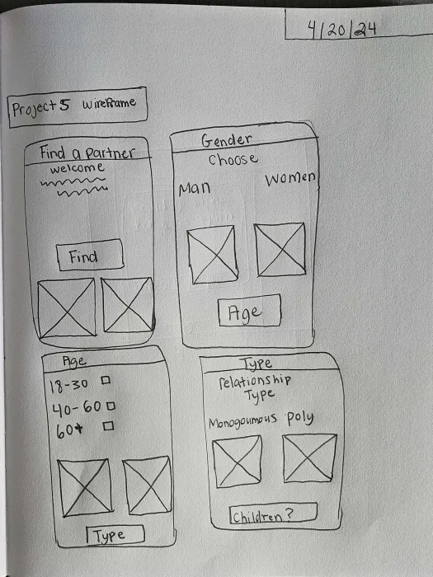

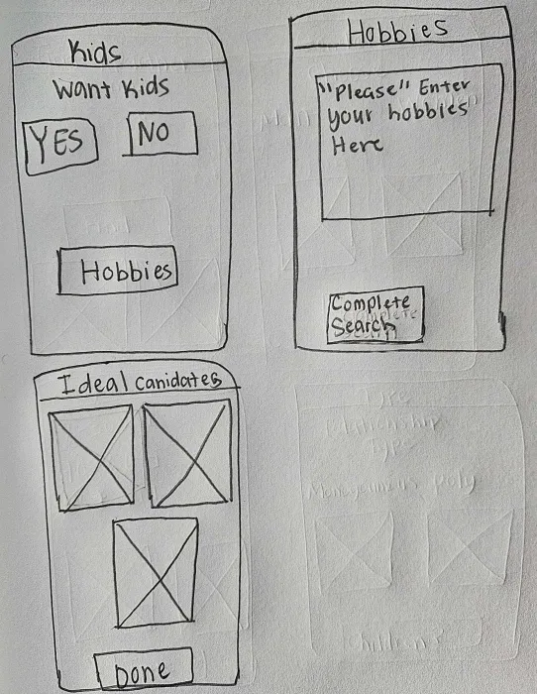

## Figma Wireframe

On the Lovequest Homepage, the user will click the arrows at the bottom to navigate to the magnifying glass to enter the Basic search feature. This feature will allow the user to select their preferences and search for users according to those preferences.

# 

The user will Next be brought to the Basic search Homepage where they will be able to add a filter and search for their partner. The filter is used to allow the user to enter their preferences for a partner. So the user will select filter.

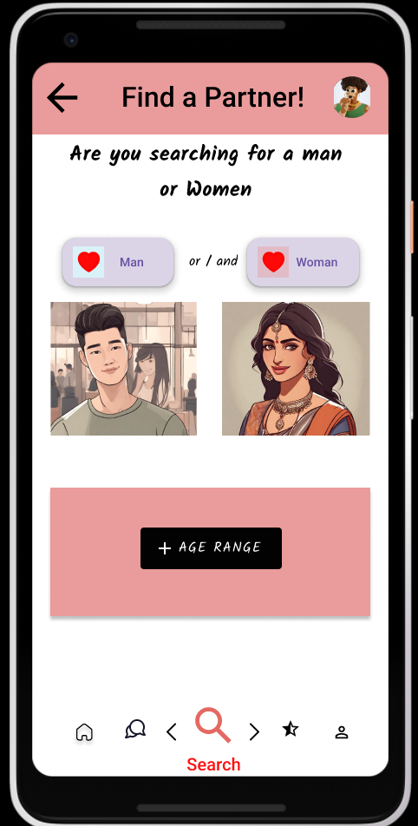

Users begin their quest by selecting the gender of their desired partner. Whether seeking a man, a woman, or both, the choice is yours to make. Once chosen, watch as the heart icon illuminates in a passionate shade of red, signaling your preference. With the gender selection made, users move forward to specify the age range they envision for their ideal partner. The user above wanted to see Men and Women as potential partners.

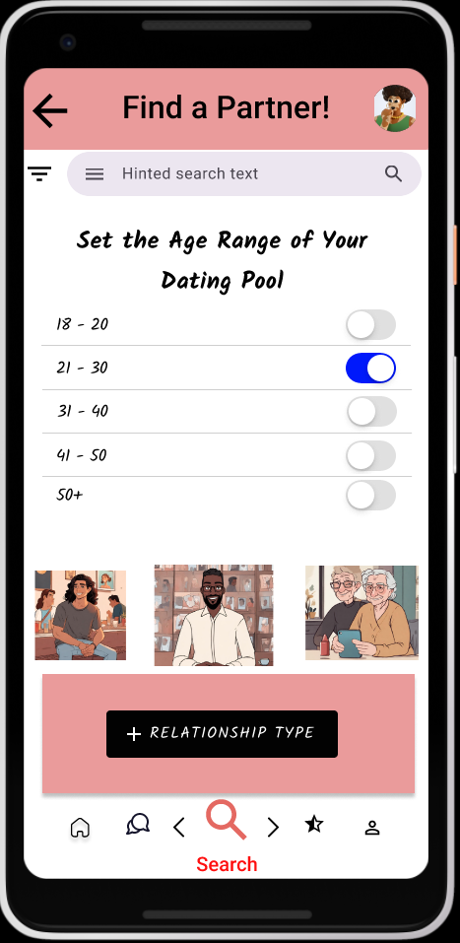

Following the gender selection, users proceed to define the age range of their potential partners within the LoveQuest app. With intuitive toggles, users can effortlessly highlight their preferred age range, ensuring their ideal partner falls within the desired demographic. For instance, if a user aims to connect with individuals aged 21 to 30, a simple click of the toggle illuminates the range in a vibrant shade of blue, signaling their preference.

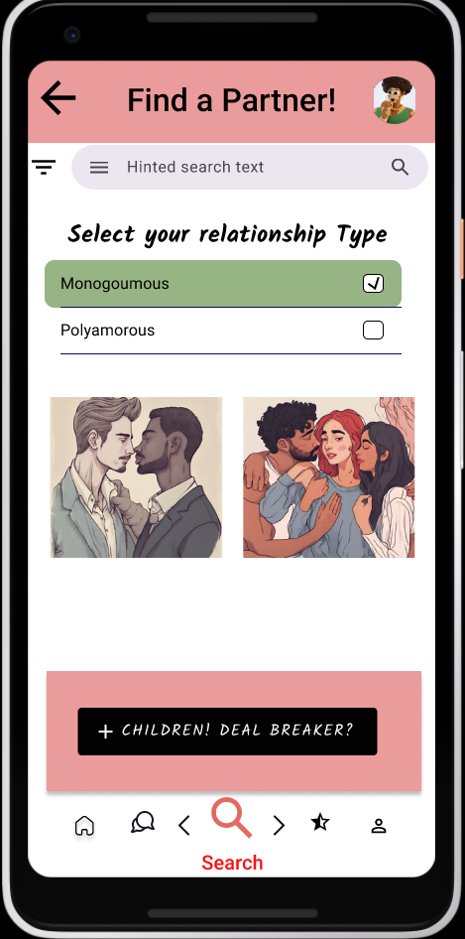

Moving forward, users will define their desired relationship type, an essential step in their journey on LoveQuest. They have the option to select between monogamous, seeking an exclusive partnership, or polyamorous, open to connecting with multiple individuals simultaneously. Once chosen, the user's preference is registered, guiding the app's matchmaking algorithm accordingly. Continuing the exploration, users then confront the pivotal question: "Children: Deal Breaker?"

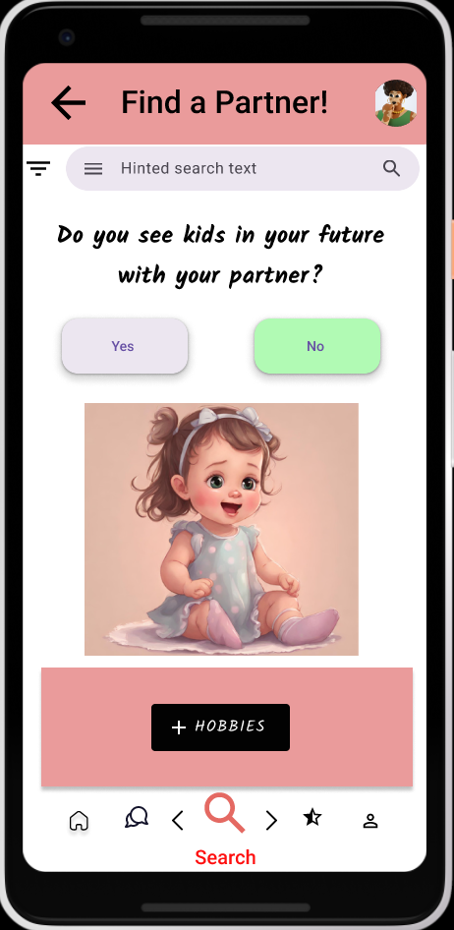

Now, users proceed to determine whether they envision children in their future with their potential partner. With a decisive click, they affirm their choice, signaling whether having children is a priority or not. The user selects No. Following this significant decision, users delve into the realm of shared interests and passions by selecting hobbies that resonate with them.

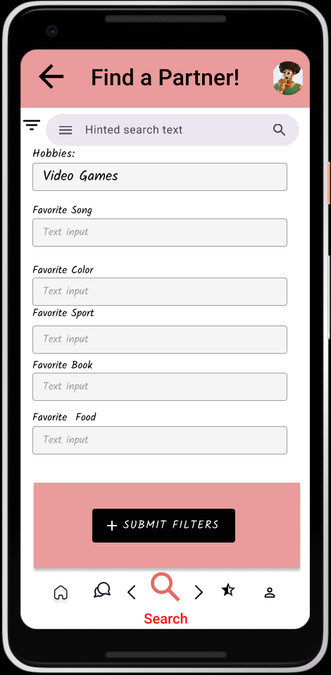

As the user advances to the next page, they encounter a canvas for expressing their interests and passions. With a simple click, they engage with the textbox and enthusiastically select "video games" as one of their cherished hobbies. This choice serves as a beacon, guiding LoveQuest to match them with a partner who shares their enthusiasm for gaming. With their preferences meticulously defined, the user confidently selects to submit all filters and preferences, eagerly anticipating the journey ahead.

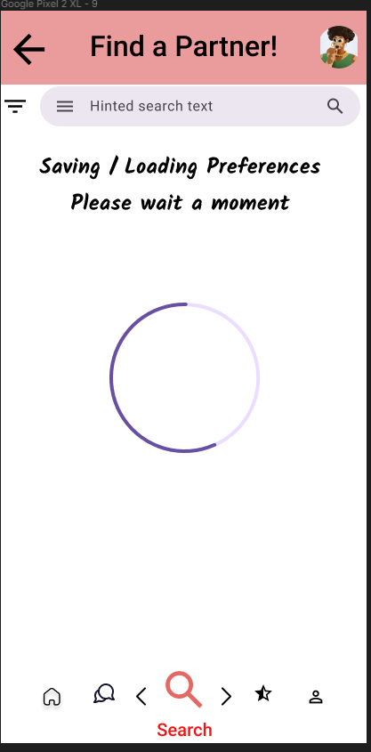

The user will then be brought to a loading screen after they have submitted their filters and it will save their preferences and load their potential partners.

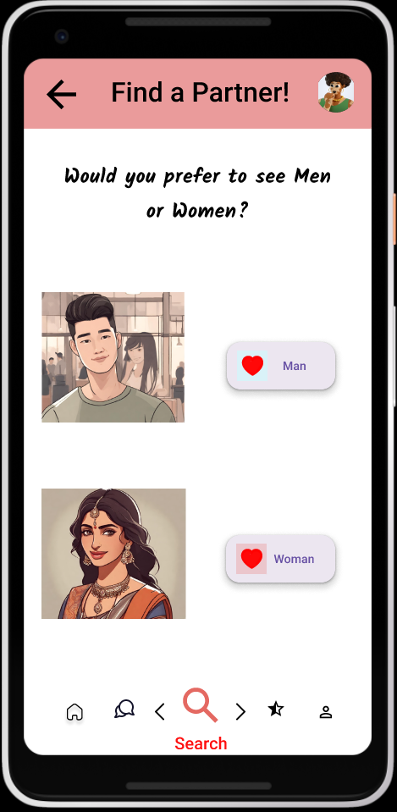

After the potential has been loaded the user will be brought to this screen that asks them if would they prefer to see the men they have matched with or the women. The user here will select the Men.

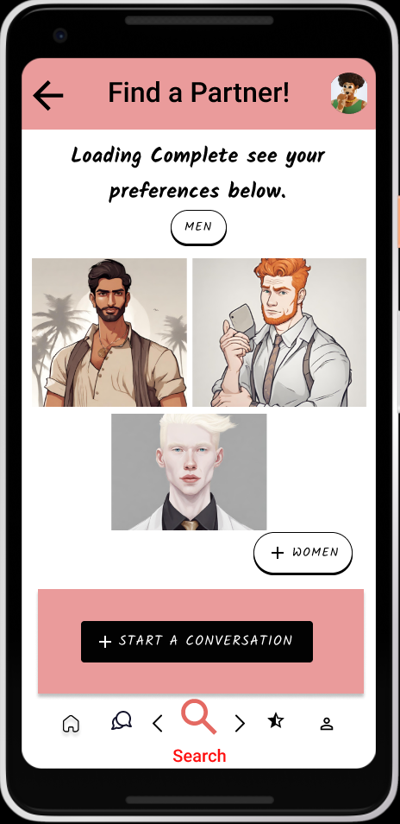  
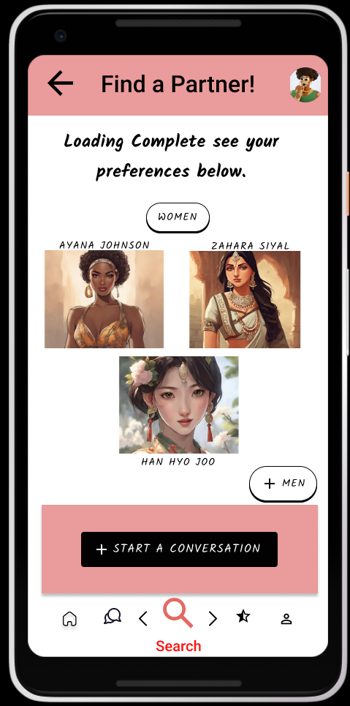

Upon reaching this page, users are greeted with a curated selection of potential partners who align with their specified preferences. Each profile represents an opportunity for meaningful connection and shared experiences. Should the user wish to refine their search further, a convenient radio button labeled "women" awaits their command, enabling them to seamlessly toggle between potential male and female partners with ease. With every interaction, LoveQuest empowers users to navigate their romantic journey with clarity and flexibility. The user will then be able to click the Start a Conversation button to be led to the communication task! The basic Search is complete.

## Interactive Elements

When conceptualizing the "Basic Search" section of the LoveQuest application, our foremost consideration was to craft an interface that embodies simplicity and user-friendliness. We aimed to empower users in their pursuit of finding an ideal partner through a series of intuitive questions. To achieve this, we incorporated various interactive elements such as checkboxes, radio buttons, and text inputs, facilitating seamless engagement with the platform.

Moreover, the inclusion of toggle features further enhances the user experience by offering a straightforward mechanism for decision-making. With just a click of a button, users can effortlessly express their preferences, streamlining the search process and allowing for more efficient matchmaking. By prioritizing ease of use and interactivity, LoveQuest provides users with a dynamic and engaging platform to navigate their romantic journey.

**Checkboxes** - Checkboxes play a crucial role in the "Select Your Relationship Type" section of the wireframe, providing users with a flexible and versatile means of expressing their preferences. By incorporating checkboxes, users can select the type of relationship they desire, whether it be monogamous, polyamorous, or any other option available. This feature grants users the freedom to choose multiple options simultaneously, empowering them to articulate their nuanced preferences.

Furthermore, checkboxes offer users the convenience of confirming their selections with a simple click, ensuring that their choices are accurately captured. Additionally, if users wish to reconsider their options or explore different relationship types, checkboxes allow them to easily deselect their initial choice and make a new selection.

**Action buttons** - Action buttons serve as pivotal components within the Basic Search feature, driving the seamless navigation and user experience across various Figma wireframes. Whether on the Gender Selection or the Would You Like Children screens, these buttons play a central role in guiding users through the decision-making process with clarity and efficiency.

On the Gender Selection page, for instance, users are presented with options like "Men" and "Women." By utilizing action buttons, users can effortlessly choose between these options, initiating distinct pathways tailored to their selection. This ensures that the subsequent screens align with the user's preferences, offering a personalized journey based on their initial input.

Moreover, action buttons offer users a straightforward means of making decisions, presenting clear choices and facilitating smooth transitions to the next screen. With their intuitive design and accessible functionality, action buttons enhance the overall flow of the Basic Search feature, empowering users to navigate their romantic quest with ease and confidence.

**Text box input** - The text input feature within LoveQuest empowers users to effortlessly express their hobbies and interests, enhancing the matchmaking process with tailored precision. With options ranging from favorite song to preferred food, users can easily input their preferences with a simple click, streamlining the experience. This intuitive functionality not only saves time but also ensures that users are accurately represented, enabling LoveQuest to pair them with potential partners who share similar hobbies. By facilitating genuine connections based on shared interests, the text input feature enriches the user's journey towards finding lasting love.  
  
  
**Toggle Button** - On the Age Range wireframe users can select the age of their potential partner by clicking on the Toggle button. Once the button is clicked it will highlight the area blue confirming the user's choice.

## 

## Design Patterns

In crafting the user experience for the LoveQuest Basic search application, our primary objectives were simplicity and enjoyment. To achieve this, we integrated design patterns such as Pagination, Cards, and a Thumbnail Grid, each contributing to a seamless and engaging journey.

Pagination, located at the bottom of the app, serves as a guiding tool, effortlessly directing users through various tasks with a single click. By utilizing intuitive icons and names instead of numbers, we ensured clarity and ease of navigation, reducing search time and enhancing overall efficiency.

The use of Cards for Action buttons offers a self-contained and visually prominent way for users to select preferences. This design choice not only emphasizes the importance of these buttons but also directs users' attention, ensuring they know exactly what action to take next. Additionally, the Cards present a uniformity in behavior for a range of options, streamlining the user experience.

Lastly, the Thumbnail Grid showcases pictures of potential partners in the Basic search task, arranged in a visually appealing and hierarchical manner. This design fosters a sense of visual cohesion, allowing users to perceive the list of matches as equals. This arrangement enhances the user's ability to explore potential partners efficiently, creating an engaging and immersive experience throughout their romantic quest.

# Task #2 - Detail Review (Adithya)

## Introduction

“Love Quest” dating website will help users get and choose their soulmates. It is a beautiful and easy-to-use interface. You can perform a lot of operations like “Basic Search”, “Detail Review”, “Communication” and “Get to Know You Activities”. With a basic search, users can enter their preferences like the age limit, and gender of their loved ones to date and finally choose their desired ones. With communication, they can indulge themselves in a chat room to chit-chat and get to know each other better. With the last task, users can spend quality time together with their preferred partners and know them better with small games and quizzes.

The “Detail Review” page of the “Love Quest” deals with viewing and managing the potential matches based on the search performed by the users. Immediately upon entering the website, users will head to search to give their preferences like gender selection, age group, and qualities. Based on the search, they are going to get some recommendations based on the matches and inputs. Now with this page, users can view and manage those matches. They have the flexibility of giving ratings to profiles and also liking the profiles for quick access.

Users can enter the page from the homepage by clicking on the “User” symbol. After clicking the icon, they will be navigated to the home page of “Detail Review”. Then they have to swipe the screen to see the matches from the search task. Along with the matches, they can see “Liked Profiles” and “Past Reviews” buttons. Initially, the Liked Profiles and Past Reviews will be empty. Users can click on any of the matches to see their profile with their avatar, full details, and preferences of the person. Then if they want they can click on the “Rate button” to submit a rating and the “Like” button to add them to the “Liked Profiles” for quick access. After filling in one rating, users can choose to exit or submit a rating for another profile. In this way, they can manage profiles, pin them, and even submit ratings which will help them to finalize a soulmate and even help others to interact with strangers.

## Wireframe Sketches

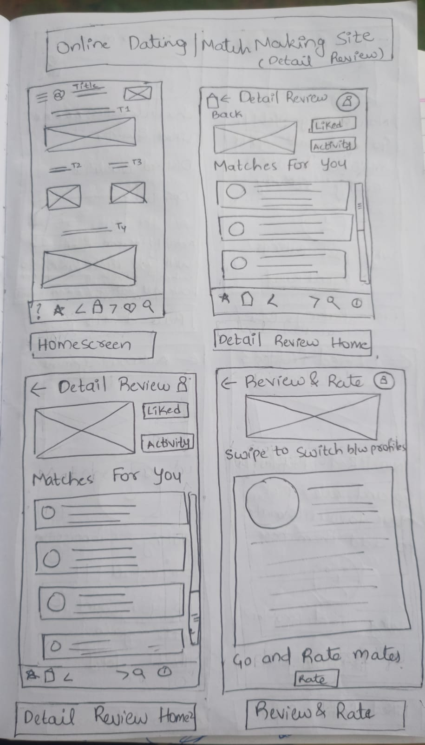

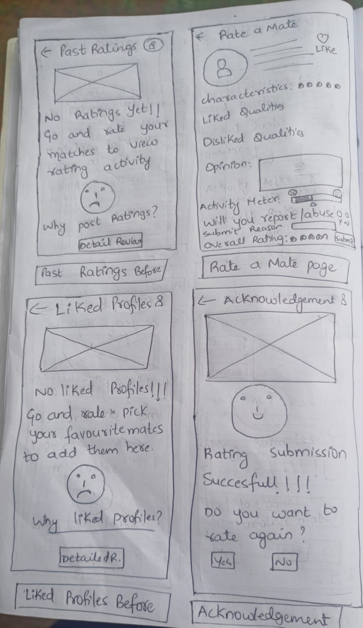

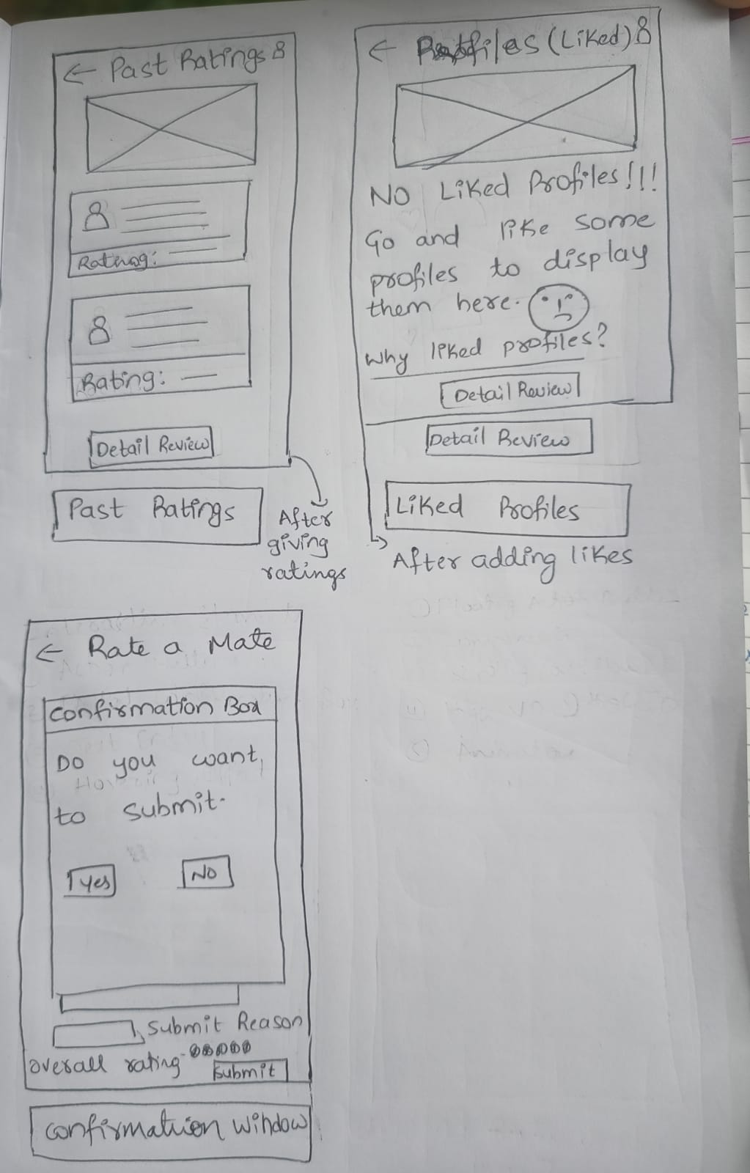

## Figma Wireframe

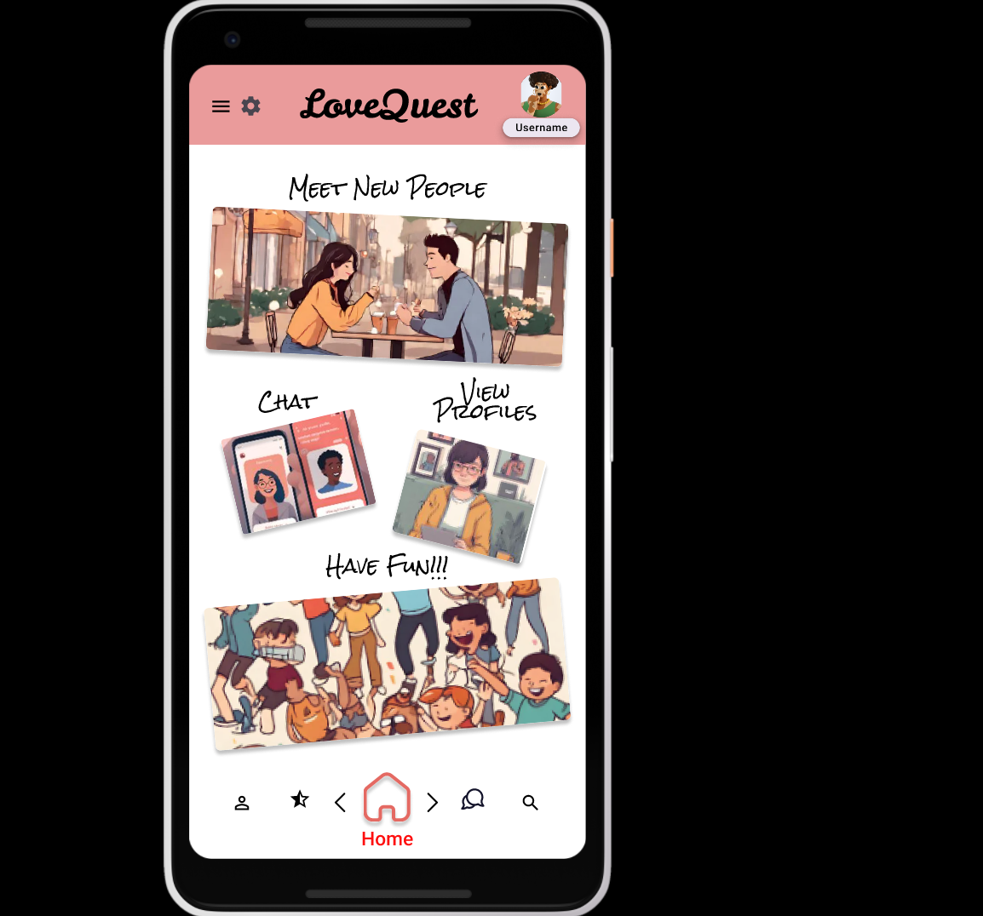

This is the homepage for the “Love Quest” web interface. We have to select the user icon (first icon) to head to the “Detail Review” page. From the homepage, we can head to any task page. Click on the “Chats” icon to head to the “Communication” task and Click on the “Search” icon to head to the “Search” page. Since we want to view the “Detail Review” page, let us click the first icon.

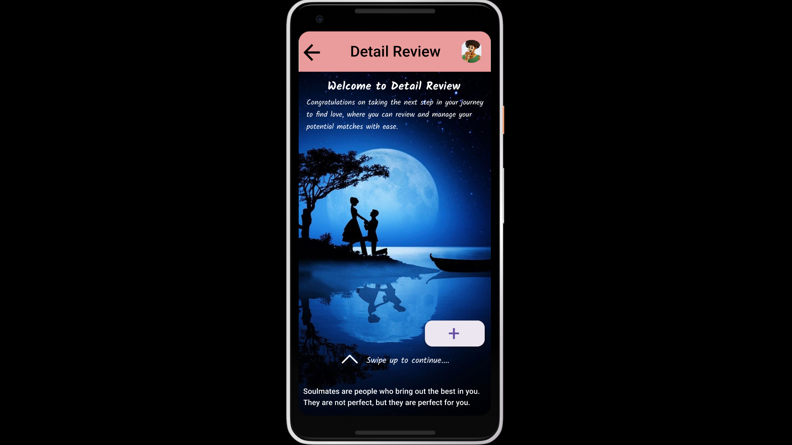

Now we are at the home screen of the “Detail Review” page. It has a welcome message, description, a prompt, and a quote. The prompt says to swipe up to view the various buttons. Let us swipe the screen.

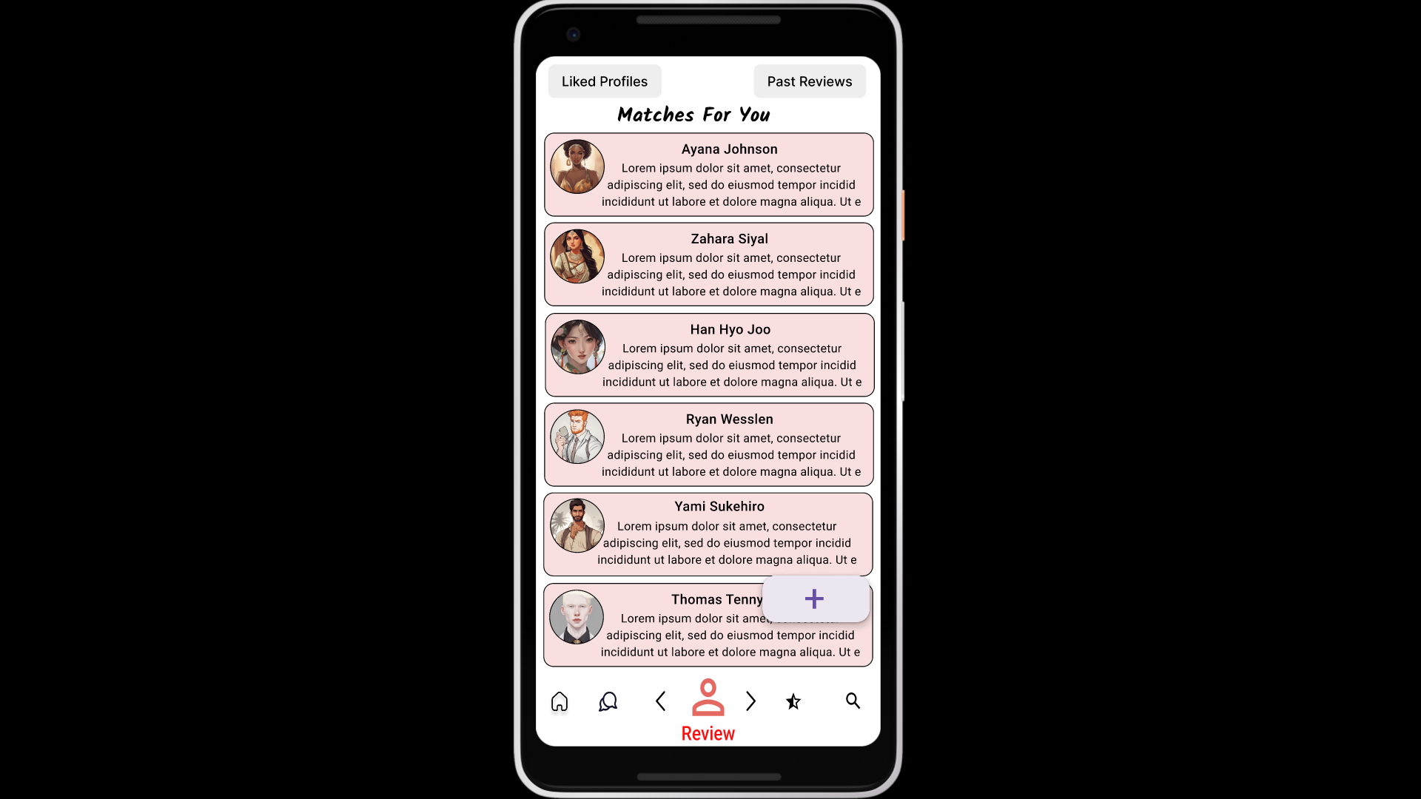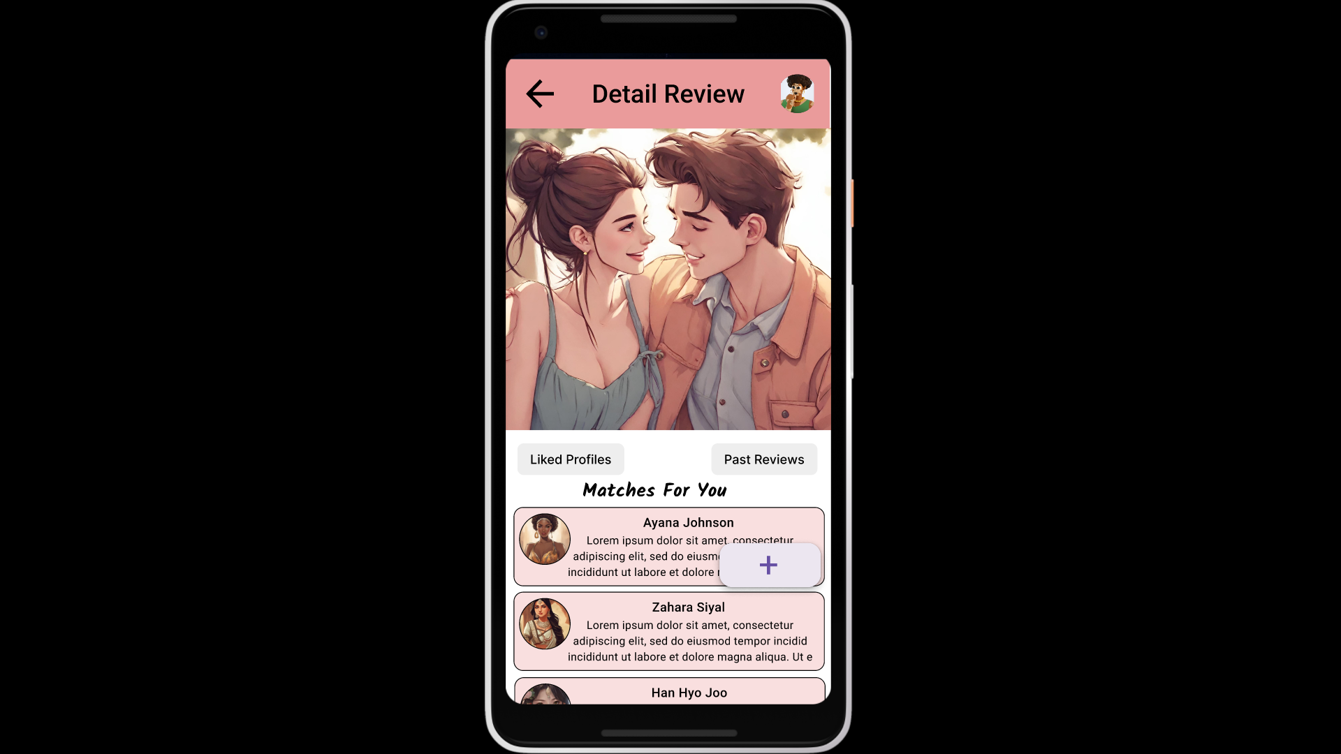

With scrolling, we can view the full page like this. Here we have all the matches from the previous task along with two buttons: “Liked Profiles” and “Past Reviews”. Let us see the “Liked Profiles” first.

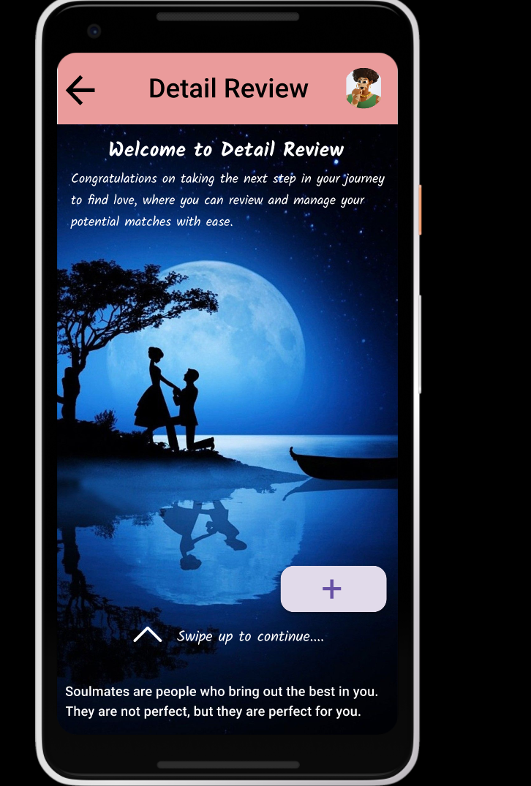

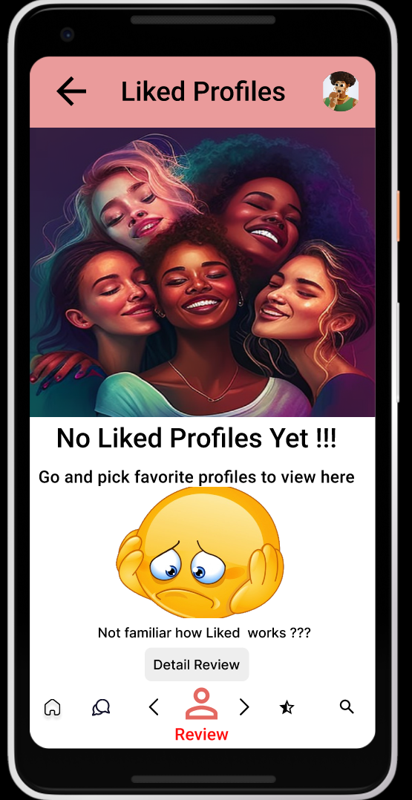

The Floating Action Button on the screen is also working. If we click it we will be directed to the “Liked Profiles” section. We can use this to easily navigate and access our liked profiles without even scrolling the first screen and clicking on the “Liked Profiles” button. Since we did not like any profile yet, it is empty. Let us go back by clicking on the back button. And test whether the alternate way “Clicking Liked Profiles” button is working or not.

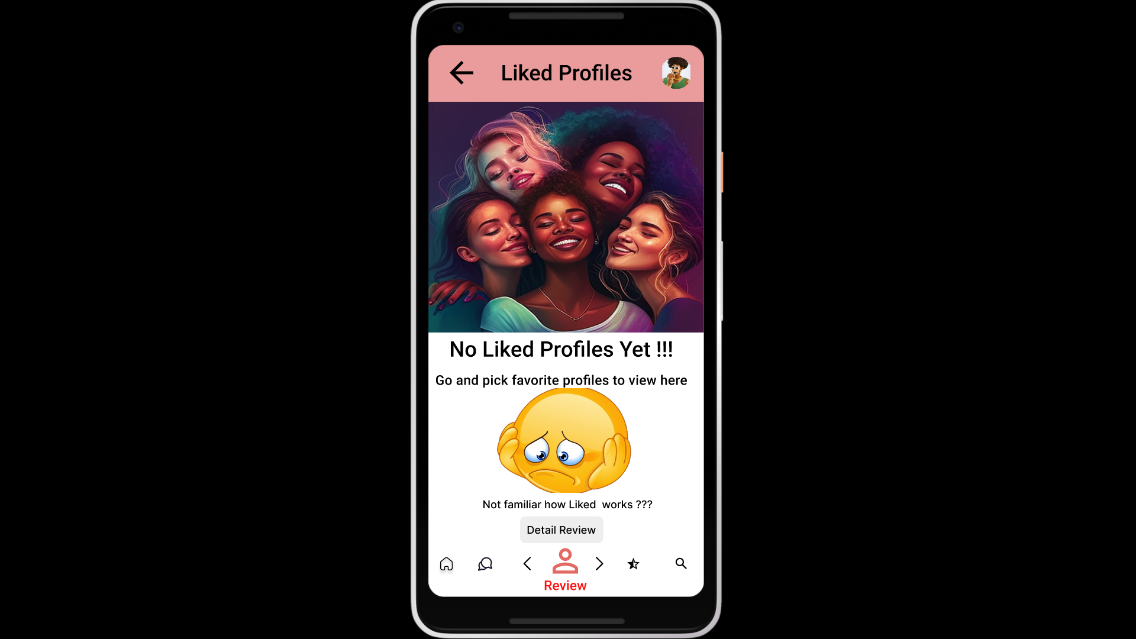

Since we did not like any profiles, the list is empty. If we are not familiar with how Liked Profile works then we can click on the link after the emoji. Or we can go back using the back button or the “Detail Review” button.

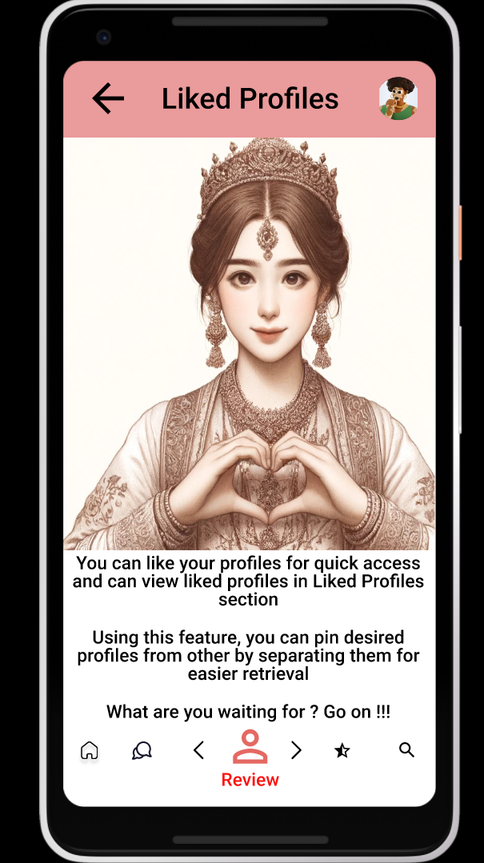

Here we have a description of the Liked Profiles section. Let us head back and go back to the “Detail Review”.



Let us click on “Past Reviews” to view the past reviews by us.

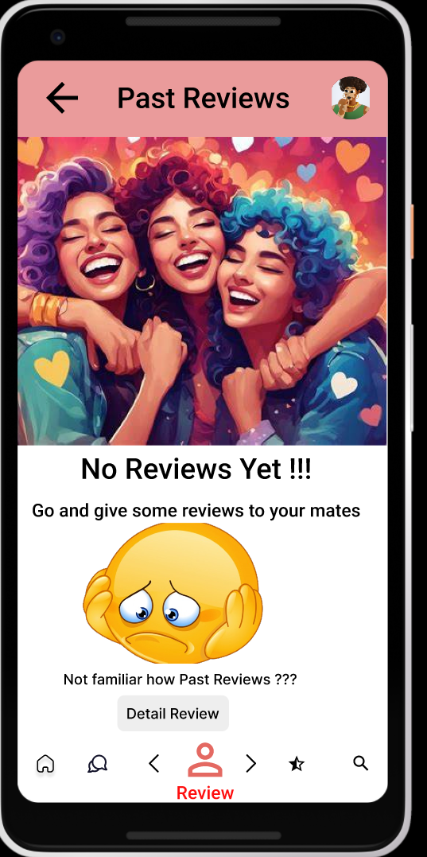

This is the “Detail Review” page. In a similar way, we can view how the Detail Reviews are working with the link after the emoji. If you want to avoid it, then you can directly click on the “Detail Review” button.

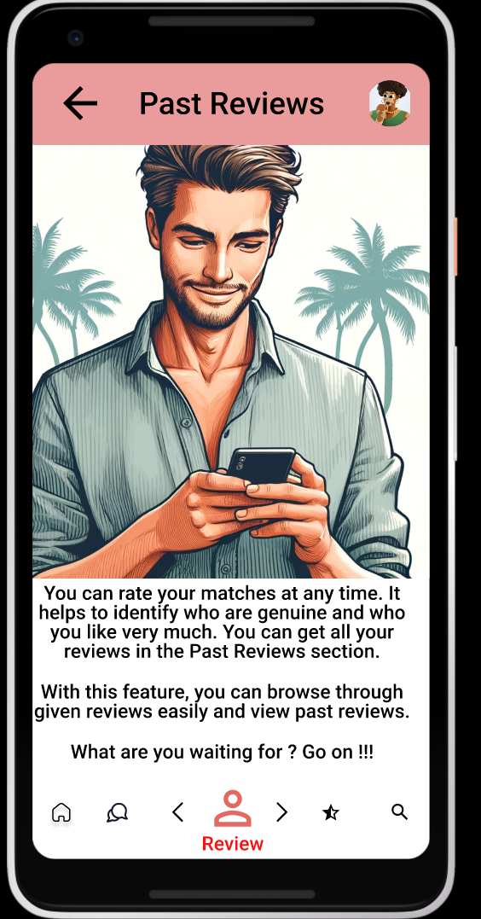

Let us go back now we have to the “Detail Review” page by clicking back twice, to the page.



Now we are back on the “Detailed Reviews”. Let us scroll back to the list of matches. We can select any personality to see a full description with their details. You can click on any match so that you can view them fully.

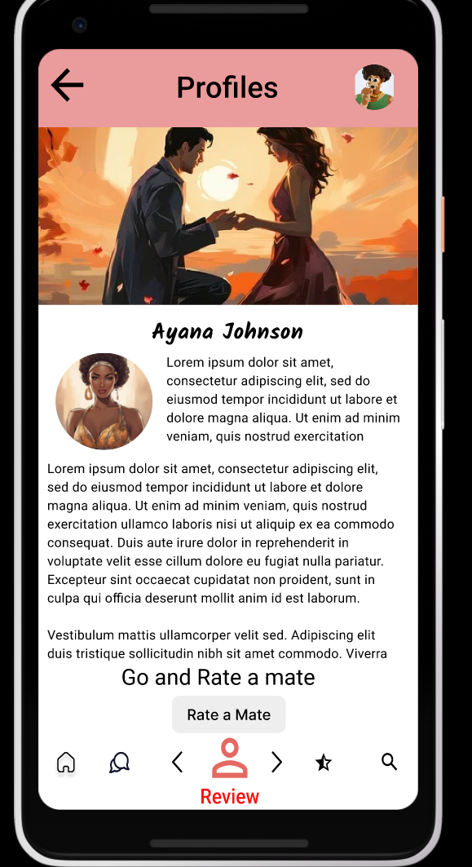

This is the full-page description of Aayana Johnson. From here we can rate them by clicking on “Rate a Mate”. You can also switch between profiles with left and right buttons in the Mobile Navigation manner.

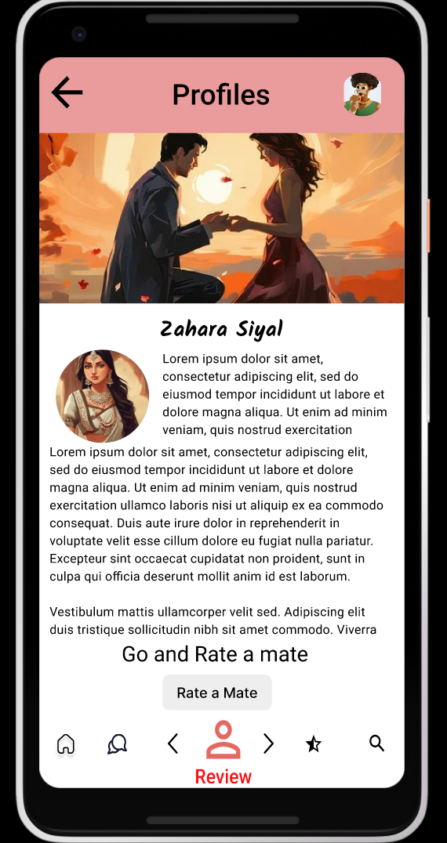

This is the “Zahara Siyal” page description. We can rate them by clicking the “Rate a Mate” button. Lets see other profiles.

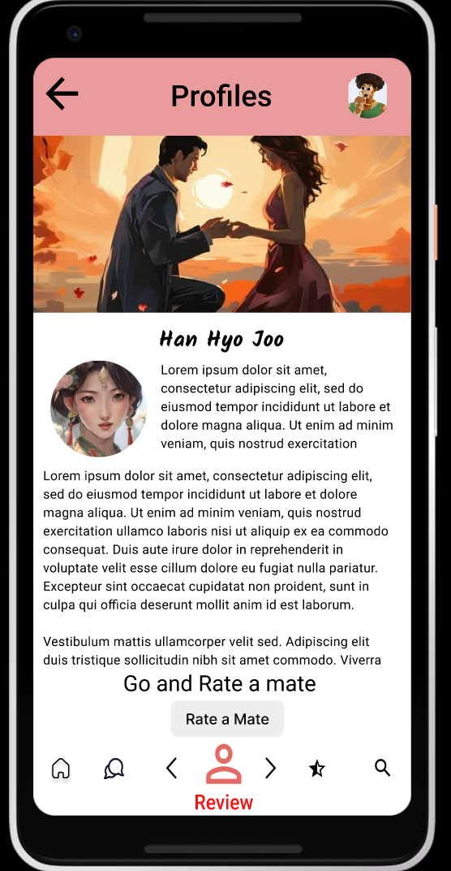

This is Han Hyo Joo’s profile with a description. Let us see the other male profiles.

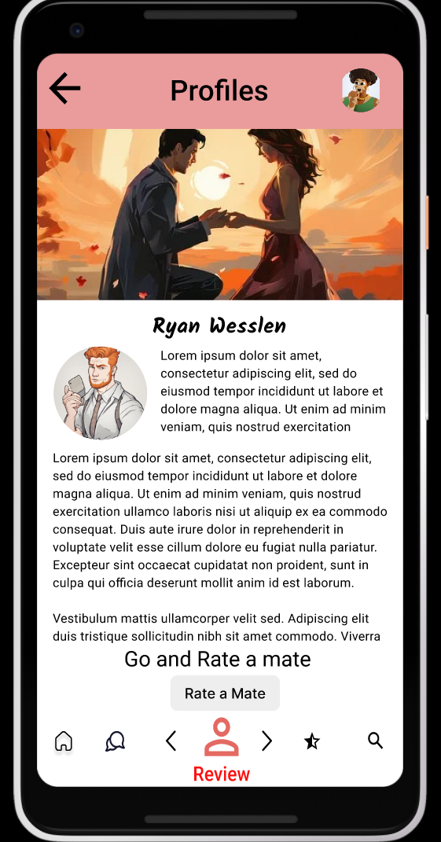

This is the “Ryan Wesslen” page profile. Here we can switch between profiles, by clicking the left and right buttons.

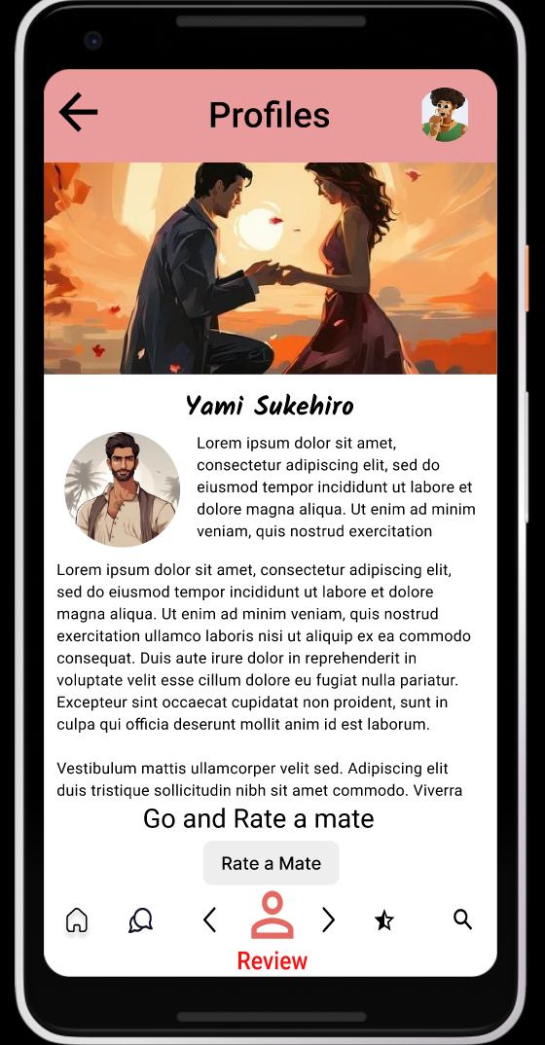

This is the pen's ultimate profile. His name is Yami Sukehiro. Click on the “Rate a Mate” button to rate his match.

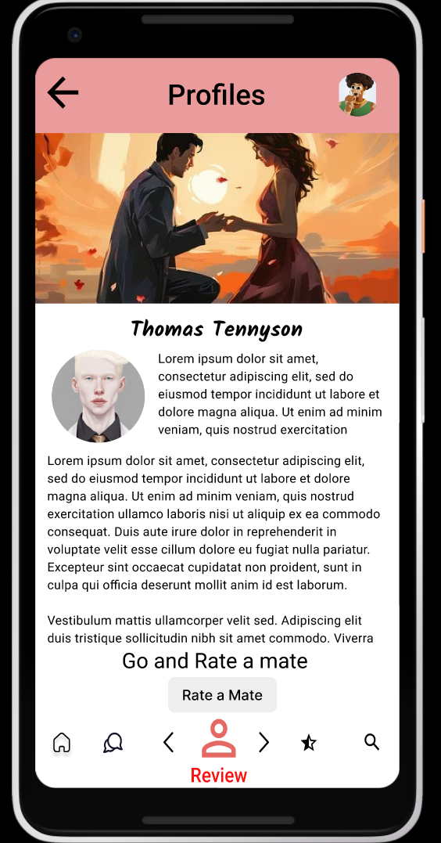

This is the last profile. His name is “Thomas Tennyson”. Now we will rate matches. We have interactions for only two profiles at the moment. Those are Zahara Siyal and Yami Sukehiro.



Now let us open the first interactive match: Zahara Siyal. Now let us click on the “Rate a Mate” and head to the rating page.

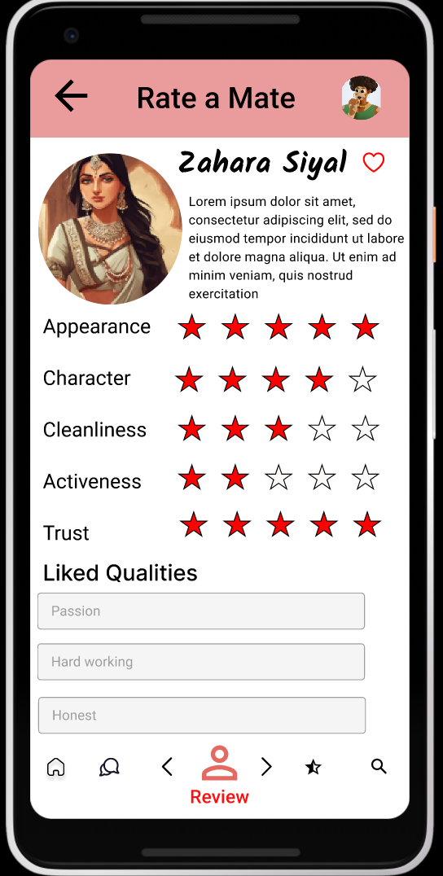

This is the first rating page. All the details are filled in. You can add anything in and fill in the details. If we click on the “Heart” symbol, you are going to like the profile. You can view all the liked profiles under the “Liked Profiles” section.

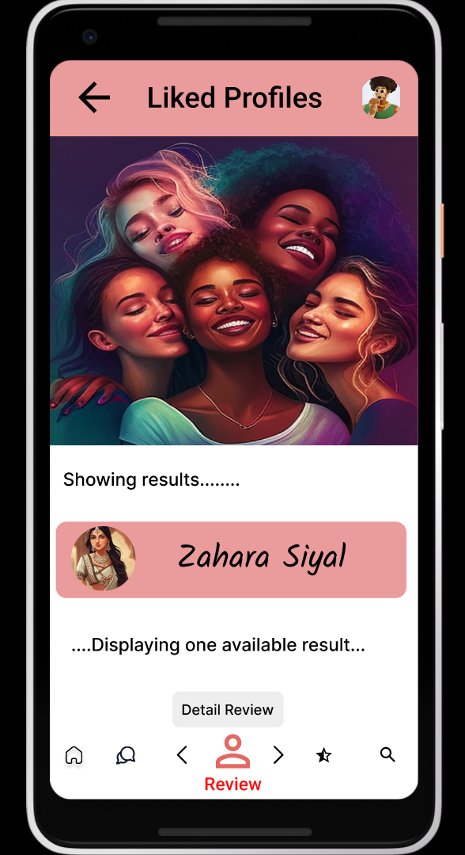

We clicked on the “Love” icon and we headed to the “Liked Profiles” page. We can go back to the “Rate a Mate” page of ‘Zaheera’ by pressing the “Back” button at the top and we can go back to the “Detail Review” homepage by clicking the “Detail review” button.

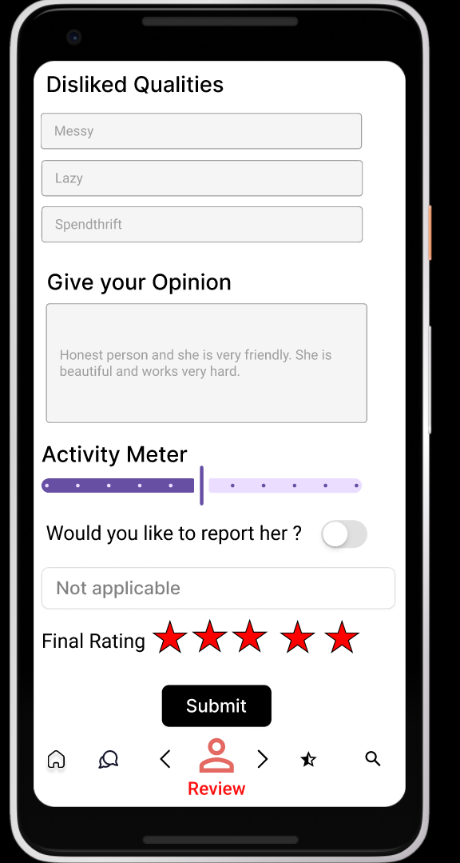

This is the second page of ratings. Fill in all the details, and after filling in all the details.

Click on the “Submit” button to head to the action confirmation window.

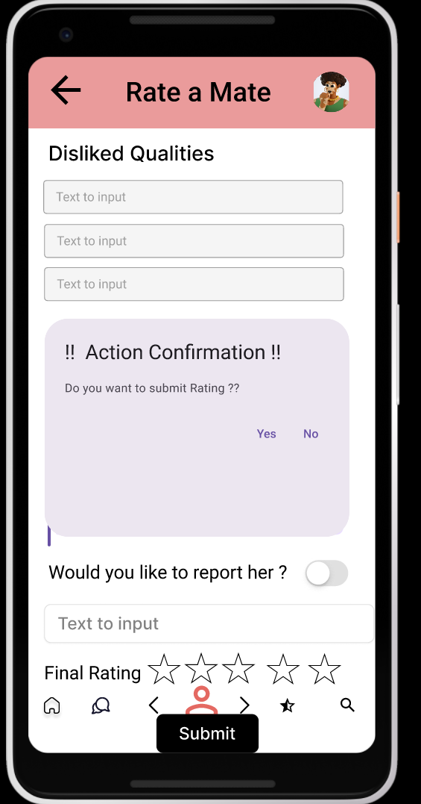

This is the confirmation window. You can click “Yes” and “No”. If you click on the “Yes” then you will get acknowledgment and clicking “No” will take you back to the filling rating of the second page.

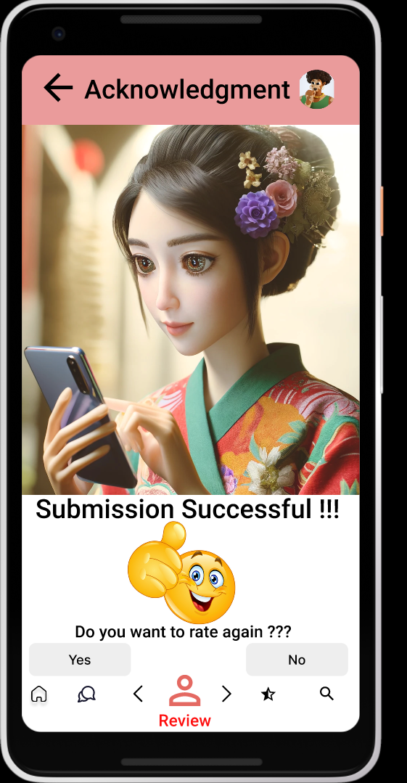

This is the acknowledgment page. You can click on the “Yes” and “No” buttons. If you click on “Yes” then it will navigate again to the matches page. If you click “No” then you will be headed to the “Past Reviews” page.

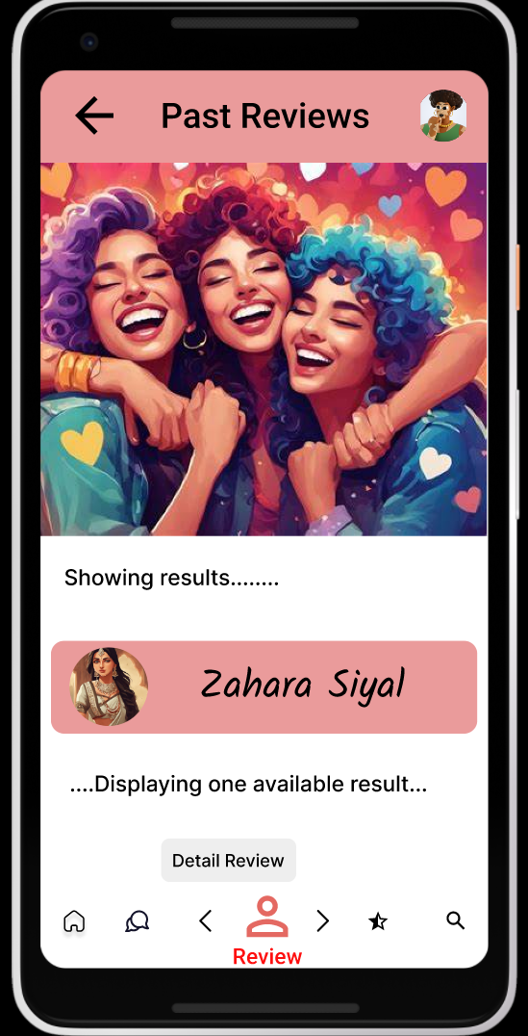

This is the updated list of past reviews given by the user. You can head to the “Details Review” homepage by clicking on the “Detail Review”.



We are back to the main page of “Matches for You”. Let us rate for another profile again.



I am again scrolling to the page details. Let us click on “Rate a Mate” and head to the rating page.

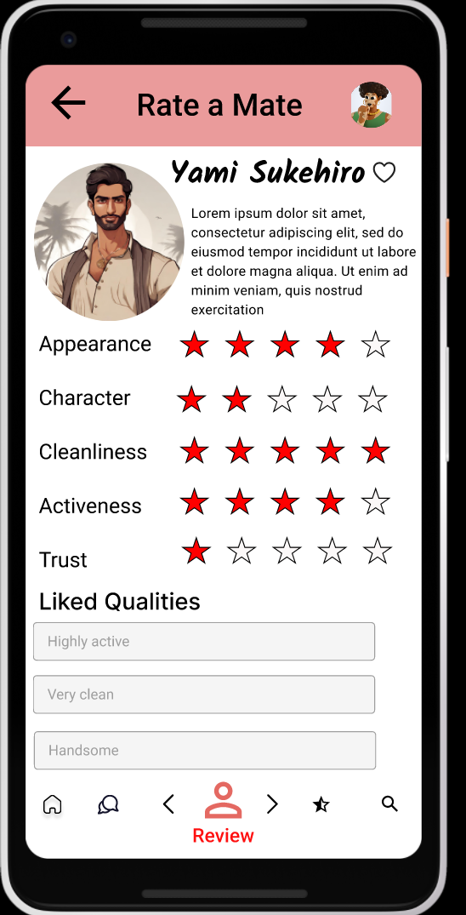

This is the first page of the rating. Fill in all the details according to the context. It is similar to the rating page of “Zahara”.

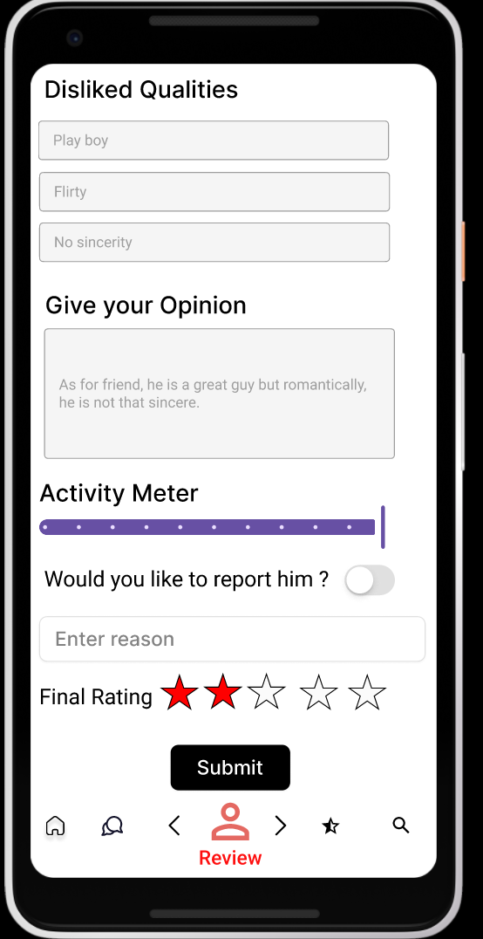

This is the second page. Fill in all the details. You can submit ratings by clicking on the “Submit” button. Then you will get the ‘Confirmation Box’.



You can click “Yes” and “No”. Clicking “Yes” will navigate you to acknowledgment and if you click on the “No” button then you will be headed back to the filling page.

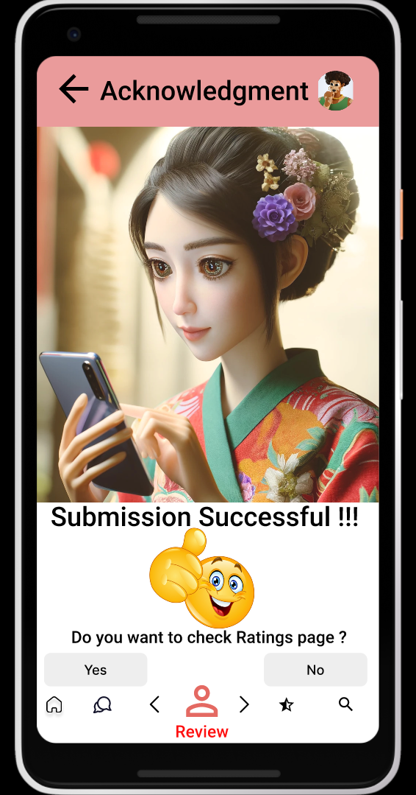

In acknowledgment, you can click “Yes” and “No”. If you click on “Yes” then you will get to “Past Reviews” with two reviews on “Yami” and “Zahara”. If you click on “No” then you will get back to the matches.

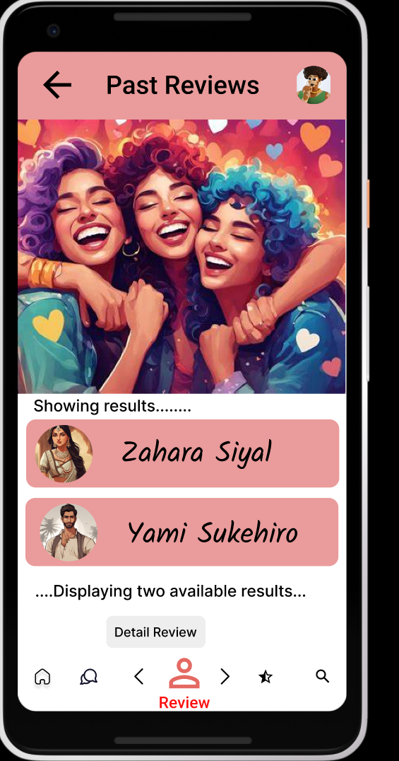

This is the last review made by the user page. Here we can view two reviews given by us. We can return to the homepage by clicking on the “home” icon (first icon).



And finally, we are back to the home screen after testing all the elements of the “Detail Review” task.

## Interactive Elements

Interactive elements refer to components within a digital interface that allow users to engage with them. Using them, a user modifies content dynamically. These elements enable users to interact with the interface, perform actions, and receive feedback in real-time.

Examples: Buttons, links, sliders, drop-down views, etc.

In the dating website “Love Quest” prototype, I have used four distinct interactive elements for designing and building the task “Detail Review”. They are Text Entry, Confirmation Box, Range Slider, and Action Buttons.

* T**ext Entry:** Text Entry is the set of items that would provide the user the ability to enter input most effortlessly and flexibly. There are a lot of components in the Text Entry like search boxes, Text Area, Text Fields, Stepper, etc. The main goal of using them is to get different types of information from the user flexibly with various types of components. The Text Entry helped users enter their desired feedback while rating their mates in the “Rate a Mate” subpage.
* **Confirmation Box:** Confirmation boxes are interactive elements commonly used in web development and prototyping to provide flexibility in double-checking before making an important decision. They typically appear as pop-up windows with a choice and a confirmation button. Alert boxes are useful for notifying users about errors and confirming actions. They generally are used before making vital decisions which change the interface a lot and have no way of reaching to step before. They provide a simple yet effective way to communicate with users and ask them to confirm their choice. They help users to confirm their choice before an important announcement or task which cannot be undone easily. The confirmation box prompted users to confirm their choice to submit ratings in this task.
* **Range Slider:** A range slider is a user interface control that allows users to select a value or a range of values from a continuous numerical range. It typically consists of a track, which represents the range of values, and one or more handles that users can drag along the track to select their desired value or range. Range sliders are commonly used in web and mobile applications for tasks such as setting volume levels, selecting prices or dates, and adjusting settings with numeric parameters. It is used to give activity for this task.
* **Action Buttons:** Buttons that act when clicked are called “Action Buttons.” They typically have links embedded inside them and function the same as links to navigate users from one location to another location within the website system when clicked. Action buttons are the beautiful and effective interactive elements to be used. Using links within them, we can navigate from one page to another easily, and they ensure navigation flow in the web interface. All the buttons to subpages like “Liked Profiles”, “Past Ratings”, “Rate a Mate”, etc. and links to navigate to other pages like the homepage are present inside the action buttons enabling seamless navigation and enhancing the user experience, providing flexibility to the user. There are action buttons to view information about liked profiles and past reviews to help unfamiliar users.

## Design Patterns

Design patterns are standardized solutions for the problems encountered by designers while creating digital interfaces. These solutions will avoid and minimize commonly made mistakes, which makes the design more user-friendly and easily accessible with no dead ends. Design patterns improve consistency across interfaces, thus enhancing the user experience.

Throughout the whole “Love Quest” web system, many design patterns are used to make users navigate between the interfaces easily and without any problems.

* **Bottom Navigation Bar:** A bottom navigation bar is a user interface component commonly found in mobile applications, positioned at the bottom of the screen. It typically consists of a row of icons or labels representing different sections or features of the app. Users can tap on these icons or labels to navigate between various parts of the app, such as the home screen, search functionality, notifications, messages, and user profile. In this task, we can see the Bottom Navigation Bar on all pages. We can navigate to the home page and other pages based on the button we click.
* **Forms:** The ‘Rate a Mate” page allows users to enter their feedback as input with all the elements in the form. The details entered are directly sent to the web and the relevant action is performed and users can fulfill their task. They further can view their past ratings on the “Past Ratings” page.
* **Floating Action Buttons:** A floating action button (FAB) is a circular or rectangular button that "floats" above the content of a mobile app's interface. Typically positioned in a prominent and consistent location, such as the bottom-right corner, the FAB is often used to represent the primary action or feature of the app. It stands out from other interface elements and remains visible as users scroll through content, providing quick and convenient access to key functionality. There is a FAB on the home screen.
* **Content Display Patterns:** Cards are used to display content in a visually appealing and structured manner, often containing images, text, and action buttons. It is a type of content display pattern used in designing the “Love Quest” web interface. All the pages include different types of data, looking like a visual feast for the eyes. There are many buttons, images, and text scattered around and kept in an organized manner. The website interface resembles a real website and offers similar types of functionalities.
* **Interaction Patterns:** Interactive element design patterns encompass a variety of user interface components and patterns that facilitate user interaction within digital products. These patterns are essential for creating intuitive and engaging user experiences across various platforms and devices. Effective implementation of these patterns enhances usability, engagement, and overall user satisfaction.

“Love Quest” web interface as a whole, along with all components of the “Detail Review” uses various design patterns and interactive elements to eliminate all the problems faced by users and engage users with dynamic interactions to ensure users have a great experience of the website. It helps users achieve their objectives effectively and flexibly, saving them valuable time and effort with all the functionalities of a real website with high fidelity with attractive visuals.

# Task #3 - Communication (Quatoria)

## Introduction

The "Love Quest" dating app's communication task is a vibrant hub where users can forge meaningful connections with both old flames and new matches alike. It serves as a dynamic platform for fostering bonds, allowing individuals to engage in lively conversations through various mediums such as text, video calls, and the innovative feature of sending video messages.

In this engaging space, users are empowered to explore the depths of compatibility with their potential partners. Whether they're exchanging witty banter, sharing heartfelt stories, or simply enjoying each other's company, the communication task offers a myriad of avenues for connection.

The app's interface is designed to encourage interaction through highly interactive buttons and features. Users can infuse their conversations with spontaneity by sending virtual gifts during video calls, adding a delightful touch to their interactions. Additionally, the ability to record personalized messages enhances the intimacy of text-based communication, allowing users to convey their thoughts and feelings more expressively.

Through the "Love Quest" communication task, users embark on a journey of discovery, getting to know one another on a deeper level. Whether they're seeking a lifelong partner or a fleeting connection, this feature provides a platform where every conversation has the potential to spark something truly special.

## Wireframe Sketching

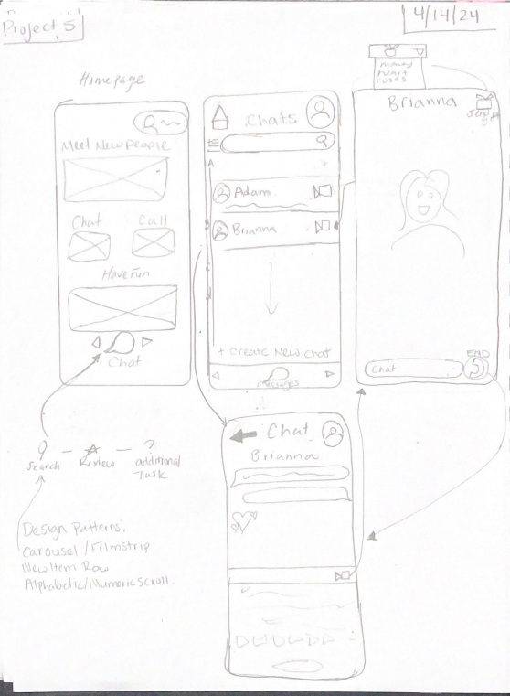

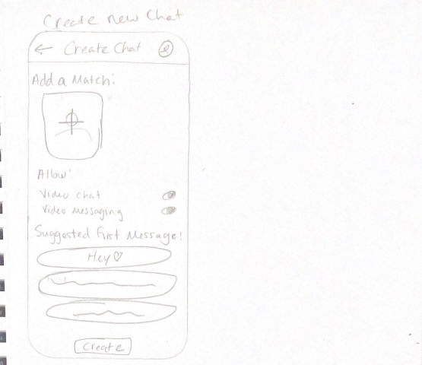

## Figma Wireframe

The user will state on the home page of “Love Quest” where they will have the option to choose between any of the different tasks available. To get to the Communication section they will click the right arrow once.

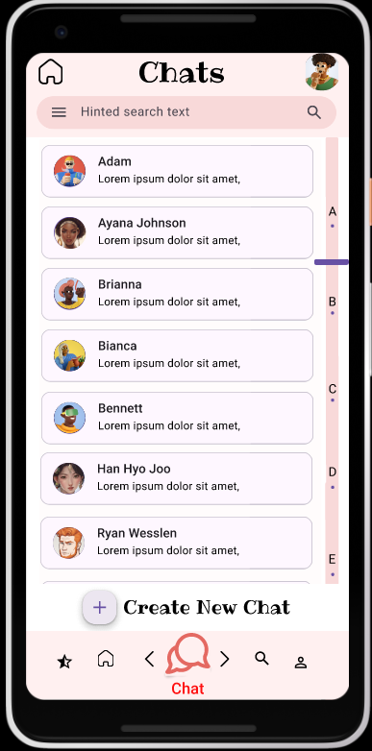

The user has now entered the hat section where they will see all the matches that they have engaged in conversation with before. They can either click on the match they would like to talk to or create a new chat with someone they have yet to speak with.

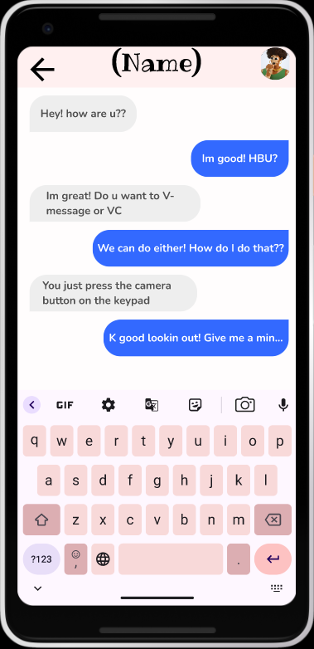

This is the screen the user will see if they choose to continue a conversation with a match. The user can chat with the match using the keyboard on the screen or they can press the camera button to either video chat or send a video message.

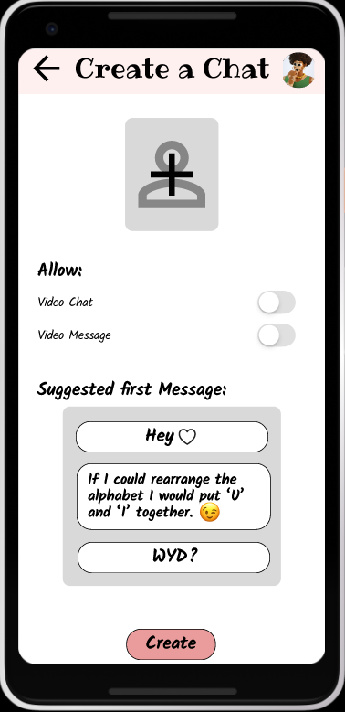

The user will be presented with this screen if they decide that they want to create a chat with a match they have yet to speak with. They have the option to select a match. Allow for video functions, and to pick one of the suggested messages to send. Once they are done they can press create which will send them to the previous screen.

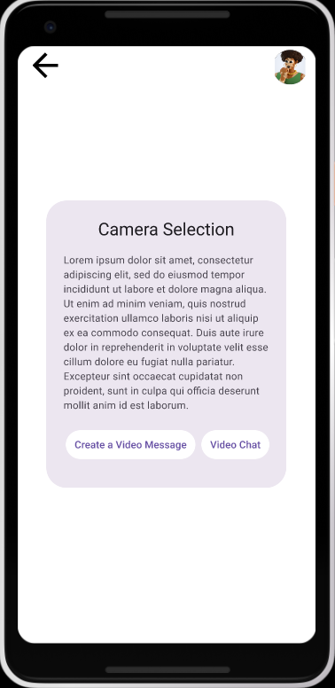

In the chat, if the user clicks the camera button above the keyboard they will see this screen giving them information about the camera selection. They will also choose if they want to do a video call or if they want to send a video message.

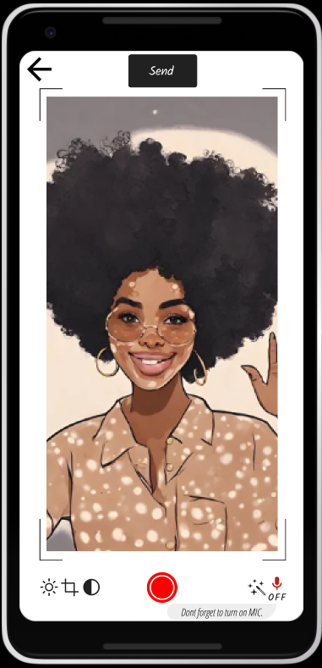

In this instance, the user has decided that they want to send a video message. They can turn on and off their microphone, press the record button to start recording, and once they are done they can send the video.

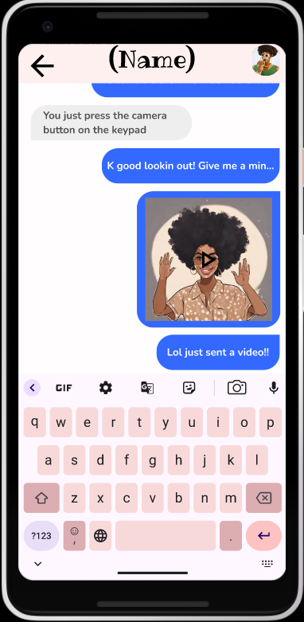

Once the user has sent the video they will see it load into the chat for their match to be able to click and watch.

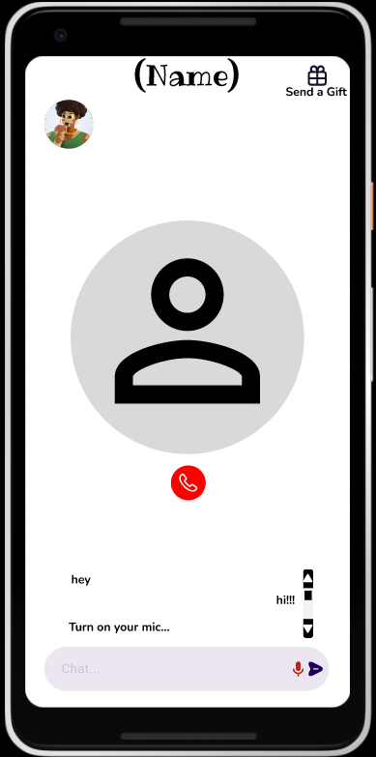

Finally, in this instance, the user has decided that they wanted to video chat with their match. They will be presented with a call interface. Where they can either turn on their MIC or use the chat function. Once they're done with the call they can press the red hang-up button.

## Interactive Element

The "Love Quest" communication task boasts a suite of interactive elements designed to elevate the user experience to new heights:

Firstly, the **scrollers** provide seamless navigation throughout the app, optimizing functionality for mobile users. Whether perusing through their list of matches or scrolling through chatrooms, users can effortlessly traverse through the interface, ensuring a fluid and intuitive experience.

Secondly, the **action buttons** serve as dynamic connectors, facilitating smooth transitions between different features and interfaces. From initiating chat rooms with new matches to gracefully concluding video calls, these buttons empower users to engage with ease, enhancing the fluidity of their interactions.

Moreover, the **search box** introduces a touch of convenience, offering users a streamlined method to locate specific matches by name. This intuitive feature minimizes the hassle of scrolling through extensive lists, ensuring swift access to preferred connections. Additionally, the inclusion of a filter bar within the search function adds a layer of customization, enabling users to prioritize conversations with favored matches or explore new connections effortlessly.

In essence, these interactive elements combine seamlessly to cultivate an environment of ease and user-friendliness within the "Love Quest" dating app. By prioritizing intuitive design and streamlined functionality, the app endeavors to provide a captivating and immersive platform for forging meaningful connections.

## Design Patterns

The "Love Quest" communication task embodies several sophisticated design patterns, each meticulously crafted to enhance user experience and functionality:

Firstly, the carousel pattern serves as a stylish and intuitive method for navigating between tasks. This sleek design allows users to seamlessly transition between different functionalities, ensuring both aesthetic appeal and practical usability. The carousel elevates the app's overall navigation to a visually engaging experience.

Next, the implementation of the "new item row" within the chat section introduces a level of control and convenience for users. Positioned strategically, this feature empowers individuals to initiate conversations with newfound matches effortlessly. By seamlessly integrating this row into the chat interface, users can effortlessly take charge of their interactions, fostering a sense of agency and personalization within the app.

Lastly, the inclusion of the alphabetic scroller within the chat section exemplifies thoughtful attention to detail. Positioned elegantly on the right side of the screen, this scroller presents users with a streamlined method for navigating through their conversations. With the alphabet laid out for quick reference, users can swiftly locate specific matches with precision and ease, enhancing the efficiency of their interactions within the app.

In essence, these meticulously curated design patterns converge to create a harmonious blend of style and functionality within the "Love Quest" communication task. By prioritizing intuitive navigation, user control, and seamless accessibility, the app sets the stage for meaningful connections to flourish in a visually captivating environment.

# 

# Inspiration

Upon making “Love Quest” we sought inspiration from dating apps such as Tinder and Bumble as they are the leading platforms when it comes to dating apps.

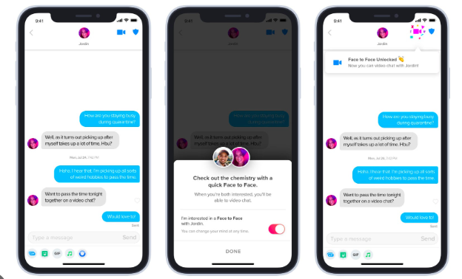

Seeking inspiration from **Tinder**, we were drawn to its dynamic communication features. Particularly, we admired the concept of seamlessly transitioning from text messaging to video chatting within the same interface. To innovate upon this idea, we introduced a toggle switch that enables users to initiate video chats at the outset of a conversation, rather than waiting for it to unlock over time. Incorporating a toggle button that requests permission for a face-to-face conversation, we've reimagined this functionality within our app.

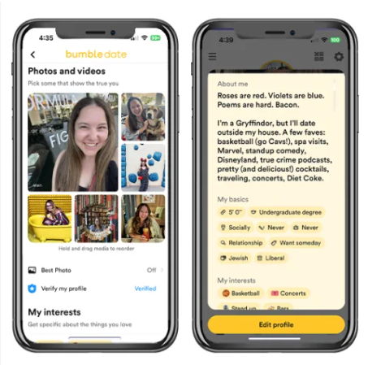

Inspired by the detailed review page on the **Bumble** app, we were impressed by its comprehensive presentation of match information, including photos and facts. To enhance our own platform, we've incorporated a unique feature: a rating section. This empowers users to rate their matches based on their preferences, facilitating a deeper understanding of their connections. By enabling users to track and evaluate their matches, our platform offers a more personalized and insightful experience.

# 

# Content-Fidelity Matrix

|  |  |  |  |  |  |
| --- | --- | --- | --- | --- | --- |
| **Content**  **Type** | *Very Low*  *Fidelity* | *Low Fidelity* | *Medium Fidelity* | *High Fidelity* | *Very High Fidelity* |
| Information Design |  |  |  | X |  |
| Interaction  Design |  |  |  | X |  |
| Visual Design & Branding |  |  |  | X |  |
| Editorial Content |  |  | X |  |  |

**Information Design:** In the Information design of the LoveQuest app, we've embraced a user-centric approach, focusing on enhanced usability and detailed comprehension. Recognizing the varied ways individuals process information, we've incorporated abundant visuals alongside textual content, understanding that imagery can often convey concepts more effectively than words alone. By making these images interactive and tightly integrating them with informative text, we've crafted a cohesive user experience that caters to diverse learning styles, ensuring that every piece of information is not only accessible but also easily digestible for users navigating the complexities of modern dating.

**Interaction Design:** In LoveQuest's interaction design, we've embraced a high-fidelity approach, implementing touch-sensitive elements that offer users a seamless and intuitive experience. Our toggle buttons in the Basic Search feature simplify the process of indicating preferences, while the ability to scroll through profiles with a click-and-drag motion in the Detail Review task mimics the fluidity of smartphone navigation. Additionally, our realistic video chat option in the Communication task ensures that users can engage in meaningful interactions with potential matches, replicating the experience found in real dating apps. By prioritizing tactile interactions and realistic simulations, LoveQuest's interaction design not only enhances usability but also immerses users in an engaging and authentic matchmaking experience.

**Visual Design & Branding:** The visual branding of LoveQuest underwent a significant upgrade, particularly evident in the Home page's high-fidelity design. Departing from mundane tabs, we opted for dynamic icons at the bottom, granting users greater freedom to navigate through tasks seamlessly. Consistency defines every wireframe of LoveQuest, characterized by a striking pink color scheme against a clean white background. We aimed to strike a balance between simplicity and complexity, ensuring users feel immersed in a visually captivating yet intuitive journey as they search for their ideal partner.

**Editorial Content:** In LoveQuest's Editorial Content strategy, we prioritize delivering insightful and engaging material that enriches users' understanding of modern dating dynamics. Building upon the user-centric approach of our Information Design, our editorial content aims to provide comprehensive guidance and advice tailored to diverse dating experiences. We leverage the power of visuals alongside informative text to create compelling narratives that resonate with users navigating the complexities of relationships. From practical tips for crafting an appealing profile to thought-provoking articles exploring contemporary dating trends, our editorial content seeks to empower users with knowledge and insights to make informed decisions on their romantic journey. By maintaining consistency with LoveQuest's visual branding and interaction design, our editorial content contributes to a cohesive and immersive user experience, fostering meaningful connections and a sense of community within the LoveQuest platform.

# User Study Setup

We have picked four users for conducting the user study task for conducting a walkthrough with the prototype to get feedback and improve the prototype further based on the critique. Each team member approached one user, tested the prototype functionality, and noted the feedback. After that, we analyzed the feedback together and then took common points, and highlighted them.

All the users tested the whole prototype (four tasks) and for each task, we have provided the prompt. Then they navigated by themselves and we helped them by providing small hints only if they were confused or lost. Then we included the goal, prompt, and feedback in the User Study Feedback section.

Users for the prototype test are:

1. **Madison Wanchia**
2. **Fabio Atayi**
3. **Vajra Kireeti Podicheti**

**Recruitment Process and Experience**:

**Vajra Kireeti Podicheti:** Adithya’s Friend

Vajra is a student working on Embedding systems. He has vast experience with various dating websites. He even made foreign friends to share and exchange information about various cultures and education systems across the globe during high school. He will be able to compare and contrast the features of websites from that generation with those of the current generation too. He tried several applications in the process. I am confident that he will be a great tester for this prototype and will be able to give a genuine review of the prototype. He will be able to identify things that will entertain the audience more and point out some things that require improvement. He tested the prototype online from India and he gave us valuable feedback after checking all the tasks for the prototype.

**Fabio Atayi:** Armel Brother

Fabio Atayi, a 21-year-old college student at CPCC, embarked on a romantic quest in search of true love before serendipitously finding it with his current girlfriend. Before their relationship, Fabio was an active participant in the world of online dating, utilizing popular platforms like Tinder, Bumble, and Hinge to connect with potential partners. His experiences navigating the various layouts and features of these apps have endowed him with a nuanced understanding of digital matchmaking, from crafting the perfect profile to initiating meaningful conversations. Despite now being happily committed, Fabio remains enthusiastic about exploring new avenues for fostering connections, making him an ideal candidate to test the innovative features of LoveQuest.

Eager to channel his expertise into a fresh venture, Fabio is excited to dive into the LoveQuest app and evaluate its potential to revolutionize the landscape of online dating. With a blend of curiosity and discernment, he approaches this opportunity as both a user and a critic, ready to provide invaluable feedback to enhance the platform's functionality and user experience. His firsthand knowledge of the dynamics of virtual romance equips him to assess LoveQuest's efficacy in facilitating authentic connections and fostering lasting relationships, underscoring his invaluable role as a beta tester. Fabio's journey from a hopeful romantic exploring the digital dating realm to a satisfied partner underscores his unique perspective and makes him a valuable asset in shaping the future of LoveQuest.

**Madison W.:** Quatoria’s Friend

Madison, a driven student at UNCG, is deeply immersed in her studio art studies while also harboring a profound interest in UI/UX design. With aspirations to secure certification in this field, she brings both passion and practical knowledge to the table, possessing a keen understanding of interfaces and a commitment to crafting user-friendly experiences. Recognizing Madison's expertise in UI/UX and her dedication to enhancing usability, she emerged as an exceptional candidate for my user study, offering invaluable insights and constructive feedback.

# 

# User Study Feedback

## **User 1:** Vajra Kireeti Podicheti

**Goal:** The main goal of the user is to navigate through all the tasks: “Basic Search”, “Detail Review”, “Communication” and the “Love Quest” prototype with prompts and provide feedback on positives and negatives for improving the prototype further by assessing and handling all the vulnerabilities.

**Task 1:** Basic Search (Armel’s Task)

**Prompt:** Begin your love quest journey by inputting your preferences for the soulmate you want to get like gender, age, hobbies, children, etc., and get relevant profiles as a result.

**Navigation:** Vajra started at the home screen and did not know how to go to the home page for the “Basic Search”. He then started directly on the home page. Then he clicked on the “Filter” button. Then he got a page to select gender “Male” and “Female”. He selected “Female” and clicked on the “age limit”. Then he selected monogamous and then he selected the age range of 21-30. He said yes he is interested in the children. He then entered the hobbies and he got the question to choose gender again. He picked and got the results.

**Feedback:** For positives, Vajra mentioned that the flow of the task and interactivity were just perfect. The layout was also consistent and good with the same structure over all the pages. He navigated easily as the structure was very user-friendly and he did not stop at any point. The toggle button interactivity was very very perfect. He said he was impressed with adding it. The idea of adding a screen with the progress “Please wait the results are loading” and shown just for some second was very engaging and attractive. He said the whole task was simple and yet effective.

As for negatives, Vajra said that he faced a lot of problems while accessing the “Basic Search” page. He got confused and did not how to open the page. He is upset that there is no easy and understandable way to access the page from the home page. He quoted that it asked for gender twice. He thinks about why to gives the same choice again after giving it once. He even suggested one idea to shorten the intervals dynamically as many of the users will prefer same-age people or people with one or two years of age gaped partners when compared with their age.

**Task 2:** Detail Review (Adithya’s Task)

**Prompt:** You should review and manage the search results obtained from the previous task by liking profiles and providing ratings to one or two profiles according to your choice.

**Navigation:** Vajra opened the home screen. He immediately clicked the “contact” icon. Then he moved to the homepage of “Detail Review”. He found the screen very beautiful and engaging. He scrolled over to the “Detail Review” home page. He said it was very easy to access. He then clicked on “Liked Profiles” and checked to see the liked profiles and he was surprised to see the interface. He missed seeing the “About Detail Review” link as he thought it was not interactive. Then he checked the “Past Reviews”, and he found it interesting to see no reviews before as he did not give any reviews.

Then he moved on to clicking the profiles and he selected “Ayana Johnson” at first and then he saw that it is not interactive. Then he pressed the back switched the profile and went with the “Zaheera” profile. He was able to find the button interactive. He is then able to find the rating page. He clicked on the “Like” to like the profile button and then he navigated to the “liked profiles”, where “Zaheera” was added instead of the normal message of showing “Nothing to show”. Then he thought it was over with one page but when he scrolled down over the second page. He then submitted and got a dialog box to confirm his choice. He clicked yes and then he got a prompt on whether to give ratings again to another profile. He clicked yes and again he was directed to the profiles page. Then he opened the next profile “Han Hyo”. This was not interactive. Then he tried the left and right buttons and he found that we can switch between profiles.

Then he clicked on the “Yami Sukehiro” profile and rated it again. He then rated and submitted. Then he clicked and opened the past reviews page. Then he navigated to the next task communication by clicking on the “Chat” icon to head to the Quatoria task.

**Feedback:**

First, let's start with the positives, the home screen was very attractive and it is easily accessible. It is very familiar to Android users. It is also very simple not complex with too many features. It has enough and minimum features to continue. The art and colors are also good. The images used were very attractive. The way of showing information about “Liked Profiles” and “Past Reviews” on how to do that. The way of showing “Past Reviews” and “Liked Profiles” is empty and then after giving ratings and liking profiles. The idea of adding a floating-point button to the head-to-liked profiles is awesome. The idea of showing descriptions along with images in the matches list. The idea of switching between the profiles with the left and right buttons was perfect.

To speak with negative points, instead of having left and right buttons to switch between the profiles, there can be horizontal scrolling. So that, without clicking the buttons, they can switch between profiles easily. The idea of adding buttons is nice but buttons are very small. They can be placed a little bit further so that users can click them easily. There are two navigation bars on the review page. It looks like there is only one page for rating. Instead of adding a menu bar again, the second page must be started so that users know there are two pages. There should have been a “Next” button on the home screen to the next page after the welcome message.

**Task 3:** Communication (Quatoria’s Task)

**Prompt:** You should navigate through the chat feature, the two main types of interacting- Video Chat and Video Message. You should also create a new chat and interact with them.

**Navigation:** Vajra was confused a little bit while accessing the page at the start. He thought it would open if we clicked on the “Chat” button but to his surprise, it opened after clicking the “left arrow” button. Then he was able to progress further without any distractions or confusion. He then came to the chat section and then opted to chat with “Han Hyo Joo”. After clicking on her profile, a chat opened and guided him to click on the camera icon. Then after clicking, it showed some text of the agreement for using the application and then it asked to decide between a video message or video chat. He first clicked on the “Video Chat”. Then he got an interface like a video chat with an avatar and a lot of options like a microphone, hang-up button, and chat box. He was able to click on the microphone button to turn it off or on. Then he hung up and then he was back at the chat window. He then clicked on the camera icon and this time, he went for the “Video Message”. Then he got a screen like a recording of a sample video with a lot of options like microphone, send button, light balance, crop, and filter options. He then clicked on the “Send” button and he could see that the video message was delivered on the chat window. He finished his prompt and was able to use the task of the prototype.

**Feedback:**

For positives, Vajra mentioned that he liked the way of creating a similar chat interface, video recorder, and chat just like a real website. He loved the message to “Turn the microphone on before sending”. He loved the way the task has a lot of options and he got the feel of a real application. He even appreciated the work of User Interface as he praised that it is awesome allowing easy navigation and looks good overall. He even added that the chat feature and video calls look natural. He particularly liked the feature of seeing the chat while on the call.

For negative elements, he said he did not get the clarity on the search box. He clicked it when it showed as an interactive element but did not understand what it did. He said that there is confusion for users while navigating to the chat page from the home screen as many users will get the feel of clicking on the chat button and they expect the interaction there instead of clicking on the “left arrow” button to get to the chat page.

**Lessons Learned:** Vajra’s feedback was very helpful as it uncovered some negative points that must be modified to improve the prototype. Some of these would have gone hidden without the user study feedback. He said that overall the prototype was excellent with a nice theme, consistent layout, and functioning perfectly with navigation and interactivity with romantic ideas. However, he suggested some modifications after pointing out some areas that need improvement. Incorporating those changes would help “Love Quest” to stand out as a great application by giving seamless navigation and great user satisfaction to the users.

## **User 2:** Madison W.

**Goal:** The main goal of the user is to navigate through all the tasks: “Basic Search”, “Detail Review”, “Communication” and “...” of the “Love Quest” prototype with prompts and provide feedback on the positives and negatives for improving the prototype further by assessing and handling all the vulnerabilities.

**Task 1:** Basic Search (Armel’s Task)

**Prompt:** Begin your LoveQuest journey by customizing your ideal partner profile, specifying gender preferences, relationship dynamics, and future visions. Once you have done so, explore your matches and see who is the right fit for you.

**Navigation & Feedback:**

Madison starts on the home screen and states that she liked the interface as it came across as inviting with the fun pictures and explaining what the user can do on the app.

She pressed that arrow key to move forward and ended up in the chat section. At first, she was confused as she didn’t understand how to get to the search task of the app. I had to guide Madison to press the arrow again after she tried clicking on the magnifying glass. She stated that it was a little confusing but understood the concept behind it.

Madison seamlessly went through the basic search task as she liked the constant design of the interface so once she did the first options, she pretty much understood what to do from then on. She commented that she enjoyed the witty questions such as the “Children! Deal Breaker?” label.

Madison's overall feedback was that she liked the simplicity of the basic research task as she didn’t have to think too hard about what to do or where to go next. She stated that the only thing she would have liked to see was when your matches were shown a description of them would have been nice not just a picture.

**Task 2:** Detail Review (Adithya’s Task)

**Prompt:** Navigate through the 'Detail Review' feature, where you can manage and rate potential matches based on your preferences, ultimately helping you connect with your perfect partner.

**Feedback:** Madison once again starts on the home screen and navigates to Adithya's page by pressing the arrow key three times. Upon seeing the interface for the detail review home page she instantly loved the aesthetic of it and stated that it gives a very romantic feel which is great since it's a dating app.

She commented that she liked it but the plus sign widget was very awkward once you scrolled up. She stated that it would be better if it was a little lower on the screen.

Madison proceeded to click on “Yami Sukehiro” and loved how there was so much personal information on him that she could rate him. She liked how spacious it was but still had a lot of information. She only commented about the doubles menu bars and was confused as to why there were 2 of them.

Overall, Madison felt that this portion of the app was the most romantic and personable as it got to let you know your matches a lot better and let you as a user rate what you felt about them. She stated other than a few visual errors she thinks there is potential after a little bit of cleaning up.

**Task 3:** Communication (Quatoria’s Task)

**Prompt:** Navigate through the “Chat” feature by creating a new chat, once you have done so explore the different chatting options with your match.

**Feedback:** Madison once again starts on the home screen and presses the arrow button once to go to the chat section.

On the chat section, she liked the scroll bar with the letters on it as it gave her easy access to go directly to anyone she wanted to talk to. However, she stated that she would have liked to see a filter option as well.

Madison proceeded to click on the Create a Chat button and stated that it was nice but could have had more color. She also liked how interactive it was and thought it was cool. She proceeded to create a new chat.

She proceeded by clicking the name of the user she just created a chat with and with a little coercion she pressed the camera button. She went through the camera process and liked it. She stated that this had to be the more interesting part of the communication task that made it stand out from other dating apps.

## **User 3: Fabio Atayi**

**Goal:** Fabio Atayi is poised to thoroughly test LoveQuest's prototype, focusing on Basic Search, Detail Review, and Communication tasks. With his extensive background in online dating platforms, Fabio's insights promise to be invaluable as he scrutinizes each aspect of the app. From his experiences on Tinder, Bumble, and Hinge, he brings a seasoned perspective, eager to provide feedback and advice to enhance LoveQuest's functionality and user experience. As he immerses himself in the prototype, Fabio's assessments will play a crucial role in shaping the future of the app, guiding it towards becoming a frontrunner in digital matchmaking.

**Task 1:** Basic Search (Armel’s Task)

**Prompt:** "Welcome to LoveQuest! Please take a moment to enter your dating preferences. Fill out the Gender, Relationship Type, Age, Children, and Hobbies sections to help us find your perfect match. Once you've completed your preferences, simply submit them, and let's see who you match up with at the end. Get ready to embark on your journey to find love!"

**Navigation & Feedback:**

Fabio starts on the homepage and compliments the pictures saying they look awesome. He automatically clicks the filter and is brought to the next page.

Once brought to the next page asking him the preferred gender for his partner he selects women. Once he selected women he thought clicking the heart would lead him to the next page but quickly found out he had to select Age Range next.   
  
  
He then selected an age range and was surprised by the toggle buttons he decided to select 21-20. When he selected age 21 -30 he liked this interactive element. Fabio did a great job going through the basic search and only had some basic questions such as why men and women show up when I only clicked on women and also asked why the search bar was not working.

**Task 2:** Detail Review (Adithya’s Task)

**Prompt:** “Go through the Detail overview and load up a profile of your choice”

**Navigation & Feedback:** While going through this task Fabio got confused about where to interact on the first screen eventually he realized that he would have to click and drag down for the screen to move.

Fabio scrolled down and decided to look at Ryan Wesslen’s profile and accomplished the task. He was wondering if Rate a Mate worked but it did not. He suggested that it was something we could add to the prototype in the future. As part of the Detailed review.

**Task 3:** Communication (Quatoria’s Task)

**Prompt:**” Start a video chat with someone on the Lovequest app. Also, message if you would like to do so”

**Navigation & Feedback:** Fabio scrolled to the chat button at the bottom of the page. He hit the chat and was shown people he could have a chat with on the app. Fabio chose to chat with Ayana Johnson.

He was then brought to the messages between them and was a bit confused about how to start the video chat. He decided to try the camera. The camera worked but he mentioned how confusing it was because he thought it was for taking a picture. He then selected to Video chat and completed the task!

# User Study - Highlight Common Points of Feedback

Positive feedback on interface Design: All users appreciated the visual appeal and attractiveness of the interface, noting elements like engaging images, consistent design, and simplicity. They found the interface inviting and easy to navigate, especially the home screen.   
  
Clear Instructions and Navigation: Users encountered confusion in navigating to specific features/tasks, such as the basic search. They suggested clearer navigation cues or instructions to alleviate this confusion and improve the user experience. Providing a “Next” button on the home screen or improving the clarity of transition between pages was suggested.

Detailed Profile Information: Users expressed a desire for more detailed information about potential matches beyond just their pictures. They suggested adding descriptions or additional personal information alongside match profiles to provide users with a more comprehensive understanding of their matches.

Communication Clarity: Users encountered confusion when attempting to initiate certain communication features, such as video chat. A clearer interface design and intuitive user prompts were suggested to facilitate seamless communication features.

# User Study - Lessons Learned

* Navigation Problems: There is a navigation issue for the “Basic Search” task as navigation to the page from the home page was confusing and users faced problems while using the task. For the “Communication” task, the “chat” button should have been for navigating instead of using the “left arrow” button for
* Usability Problem: The “Search Box” on the “Communication” and “Basic Search” tasks was very confusing. It was like an interactive element but users did not why it was present as an interactive element or what it achieved when clicked.
* Suggestions on Design and Exploration: There are some suggestions to include horizontal scrolling to the profiles like in Tender instead of having left and right buttons to switch between the profiles in the “Detail Review” task. In the same task, there should have been a button to show the next page of rating like “next” instead of creating two menu bars as giving that makes a feeling that there is only one page for rating. For the “Basic Search” task, there should be redefined filters like a slider for giving partners suggestions of the same age or with two or one age gap in the partners.
* Problem with Buttons: For the “Detail Review” page, the floating point button is very big and it is a bit distractive. It deviates from the content and it should be a bit small. The left and right buttons to switch between the pages are also very small and there might be a chance of mis-clicking. If the partition between buttons is good then there will be a high chance of clicking the right keys for the users. For the “Communication” page, the mic button is very close to the filters and the interaction for the microphone gives a wrong feeling that the filters are also interactive.

With these minor modifications, “Love Quest will be more interactive and provide seamless navigation ensuring a great experience for users helping them them meet their soul mate and bring them together.

# Overall Team Project Reflection/Critique

Our team has put a lot of effort into creating “Love Quest”, a dating web interface, that consists of four main pages each performing its task: Basic Search, Communication, Detail Review, and dashboard. It is the perfect time to evaluate our work, talk about how well each task was completed, and coordinate the interface designs throughout the program. Evaluation will give valuable insights into the current state of the prototype design and improve it further by assessing the impact of negative points. The prototypes require frequent checks and modifications at each stage to get a good model, and every model needs continuous integration and follow-up.

We decided on the name, and logo before we split the tasks between ourselves. Hence, you can find most things similar across our prototypes even though we divided work into individual tasks, planned prototype designs, and made them individually. We were collaborating, correcting each other's mistakes, and evaluating each other's ideas, which symbolized this as a single project. All our interfaces resemble similar structures with consistent layouts starting from the “Google Pixel 2 XL” mobile layout and a similar type of menu navigation bar with links to all the tasks along with the homepage. All the buttons for main pages and subpages are present for all tasks. The consistent layout, logo, and all the similarities in the web interface also resemble our coordination. As a whole, even though the way of designing and implementing ideas varies from person to person, the web interface has been consistent and the same. The interactive elements and design patterns also vary based on one's mindset and the functionality of the task. But the overall theme of the dating website will stay the same covering all aspects of the real website like searching for soulmates with inputs by applying various filters, chatting and video calling with various persons, managing profiles along with rating them and pinning them to profile by liking the profiles and support for roommates making “Love Quest” website an attractive, interactive and better website than existing ones to find your soulmate.

**Basic Search:-**

**What worked well:**

* The way of asking for various inputs was attractive and the selected choice highlighted in green color is very flexible and it shows what we selected for the users.
* The way of linking it to the chat task is very flexible instead of normal buttons after selecting the girl and boy. The features of selecting multiple soulmates are also very nice. It allows freedom to make any choice in real life.
* The layout remains constant throughout all the tasks. The two images and one box with a one-word description of the filter name are stuck and repeated across all the pages.
* The idea of displaying saving/ loading preferences, please wait for some time is very unique. And the images used in the task are attractive.

**Areas for improvement:**

* There were pictures in the results. If there is some short description about themselves then it would be perfect so that we can get an idea with just a glance at the profile with avatar and description.
* The search bar was not working. If it was not an interactive element, then it could have shown differently with the rest of the interactive elements.

**Detail Review:-**

**What worked well:**

* The links at the bottom navigation bar are correctly working and adding navigating buttons to home and other pages is very helpful for users.
* The website resembles a real website with several interactive elements depicting all possible paths and having the option to switch between the profiles was perfect. There are both horizontal and vertical scrolling according to the context.
* Rating a mate page is appropriately designed. Appropriate use of text entries was done according to the context and type of input. The idea of adding separate pages to give an idea of how “Liked Profiles” and “Past Reviews” work for unfamiliar users can be appreciated.
* Emojis and images were used perfectly. Overall application was very engaging and attractive with higher fidelity elements all over the page in an organized and structured manner. They provide more clarity to users giving a rich look instead of deviating from the goal of the application.

**Areas for improvement:**

* The left and right buttons on the navigation bar were used only for switching profiles in the “Profiles” section. They are not used in other instances. It is better to use them fully maintaining consistency.
* The given inputs are not visible in the confirmation windows while submitting the ratings. They should be shown beneath the box to give users an idea of what they have entered. It does not provide the idea that the website is continuous and all pages are linked.

**Communication:-**

**What worked well:**

* The chat interface looks realistic with vertical scrolling and all the profiles are in alphabetical order. All the screens look amazing and interactive, especially adding a new profile will leave a great impression and satisfaction.
* The chats are also in the familiar format of Instagram, the famous Meta Application for browsing and chatting. The inclusion of a keyboard looked realistic and having a camera icon on the keyboard was a great idea.
* The agreement page while the camera is selected is way realistic just like a real-time chat application to make sure that users agree to all terms and conditions while using the camera feature.
* The video sent acknowledgment and the interactive message “Please don’t forget to turn on the mic” was very attractive and engaging. It reminds users to switch on the mic before recording a video message or video calling someone.

**Areas for improvement:**

* The search bar on the top is not easy to use. It looks like an interactive element. It functions but it should have been very simple to use by functioning with a single click.
* The “left arrow” button on the home page helps to move to the chat feature. “Chat button” should have been used for that as any user on first glance will connect and expect to click the “Chat” button.

**Overall Application:**

**What worked well:**

* The coordination can be seen in terms of logo and consistent layout across all the pages. The consistent layout, bottom navigation bar, and use of logo, font, and texture will certainly attract any user. They indicate that all the pages and tasks belong to the same web interface “Love Quest”, a matchmaking web interface.
* Almost every page has some unique interactive elements based on the context, and they are implemented well in the prototype. In most cases, interactive elements are differentiated from other static elements.
* The persons are the same within all the pages which strongly proves the coordination between teammates. The first “Basic Search” page got results of three boys and three girls and the same persons again appeared in the “Detail Review” task. There is complete consistency between the tasks without any deviation or rise of doubts. Immediately after getting results based on inputs, they can directly head to chat (task 3) from task 1.
* Almost every webpage has a lot of buttons, submit and back buttons, on the webpages to move further or go back if something is wrong. With these buttons placed on all pages, users can effortlessly navigate across sub-pages. Every page has a variety of design patterns and interactions with unique functionalities of their own. The interactions were realistic just like a real website.
* The “Basic Search” with different and realistic input choices to apply filters and get recommendations of boys and girls; “Detail Review” with a lot of attractive images and information pages for getting familiar with what to do with ‘Liked Profiles’ and ‘Past Reviews’; “Communication” with the realistic implementation of video call and video message especially with reminder ‘Do not forget to turn on the mic’ ‘Camera Setup prompt’ done a great job. These all elements give the prototype a realistic view like a real website instead of a prototype.
* Throughout all the tasks, the prototype has high definition attractive images and the fidelity is also high. The application demonstrates a high level of consistency in terms of design, navigation structure, and user interaction almost across all subpages. The website looks romantic with a lot of attractive images and a nice theme with a lovely title.

**Areas to improve:**

* There was one difference between the tasks. If you want to enter the “Communication” task you have to click on the right arrow once but to enter the “Detail Review” page, you have to click on the “Contact Icon”. There should be similarity and consistency between the tasks. They have to discuss and select one way instead of going with various ones.
* There is a 'navigation bar’ at the bottom for all the pages in the tasks “Basic Search” and “Detail Review” pages but that is present in only two pages for the “Communication” task.
* Websites should have some more choices for giving full freedom to the user to pick anything they want. For example, the inputs in most of the pages were restricted and immediately after clicking a button, all the fields were filled. Or one field is filled after clicking a button.
* Even though a good interface is being released at the moment, it is not over yet. It needs proper maintenance and a lot of new trending features must be embedded with the flow of time. Continuous integration and proper checking must be done again and again.

**Conclusion:**

The house rental web interface “Love Quest” presents meticulously crafted tasks, each designed to elevate the user experience in unique ways. The intuitive features like searching for soulmates by entering some preferences to filter out the ones suitable for us from the rest, reviewing and managing the profiles of potential matches along with like profiles to pin them for easy access or rate them for future references, and flexibility to video call or send a video message to our favorite people to spend quality time with them and to get to know them better. “Love Quest” has created a hub for all people who are looking for soulmates. It is one of the best mobile web interfaces for matchmaking with a lovely pink interface, attractive images, romantic quotes, an easy-to-use interface, free interactivity, and flawless navigation. There were very rare minor differences like a variation in heading to a task page from the home page and the absence of a bottom navigation bar across some pages while it is present on every page for some tasks. The presence of the same layout across all the tasks, the same logo, textures, and fonts with the same search results across the tasks override the minor differences and strongly present the idea of one web interface. Most of the inputs are restricted but enabling full freedom for the inputs could have created confusion among the users and designers due to the large number of pages with distinct possible paths. With all those, it could have been a more realistic website with very high fidelity rather than a prototype. It could cost a lot of time and effort and it will be exaggerating for the prototype to invest more time and effort, which makes it reak website rather than the prototype. Overall, “Love Quest” stands to be an attractive, interactive, and romantic match-making web interface enabling good navigation, outstanding design, a lot of interactivity, vibrant themes, attention-catching visuals, and delivering a unique experience and great satisfaction as the prototype with the feel of a real website.